Linear Algebra for Machine Learning

Contents

Linear Algebra 4

Linear System of Eqn Basics: 4

Links 5

Vectors 5

1 X 2 Matrix 6

Vector? Column or Row 7

Vector? Arrow or point 7

NOT COORDINATES but MOVEMENT: 8

Basis Vectors: 8

Vector Addition/Subtraction (numeral) : 9

Vector Scalar Multiplication 10

Vector Multiplication visualization: 11

Span: 11

Linear Dependence: 12

Linear Independence: 12

Linear Combination 12

Linear Transformation 13

Matrix: 16

Matrix Multiplication: 17

Vector/ Matrix orientation 20

Matrix Multiplication Properties: 22

Important term definitions: 23

Inverse Matrix - Intuition 23

Non- Invertible Matrix 24

Pseudo - Inverse Matrix 24

Column Space 24

Rank 25

Basis - Advanced: 25

System of Equations: 26

Determinant of a Matrix – Intuition 26

Basis Advanced Topics 26

Changing the “Basis” 27

Projections: 29

Scalar Projection: 29

Orthogonality and Orthonormality: 31

Gram-Schmidt Orthogonalization process: 32

Inverted Matrix 32

Matrix Invertibility Criteria: 32

Gauss-Jordan Method: 33

Homogenous and inhomogenous solution set 34

Linear Systems and different ways of writing it: 35

Types of Linear Systems in Three Variables 35

Gaussian Elimination: 37

Row Echelon Form: 38

Augmented Matrix: 40

Free Variable / Parameter : 40

Example of Gaussian elimination and parametric form: 42

Span: 43

Spanning set: 44

Vector Space : 44

Subspace: 44

Rank 44

Dimension of the solution set 46

Different applications of concept of dimension: 46

Column space/ Range of matrix: 47

Application of Column space: 48

Nullity of matrix 49

Null space 49

Rank-Nullity Theorem: 50

Maximal Linearly Independent set: 51

# Linear Algebra

Linear algebra is a branch of mathematics that focuses on **vectors, matrices, and linear transformations**. It deals with **solving systems of linear equations**, performing operations on matrices and vectors, and understanding geometric concepts such as lines, planes, and rotations. Solving systems of eqns is the biggest application in ML Algorithms.

Key concepts include:

* **Vectors**: Quantities with both direction and magnitude.
* **Matrices**: Rectangular arrays of numbers that represent transformations.
* **Linear transformations**: Functions that preserve vector addition and scalar multiplication.
* **Dot products, cross products, and norms**: Measures of magnitude, direction, and relationships between vectors.

**Why the Name "Linear Algebra"?**

* **Linear**: Refers to the fact that all relationships and transformations in linear algebra are based on **linearity**—meaning they preserve:
  + **Additivity**: f(a+b) = f(a) + f(b)
  + **Scalar multiplication**: a . (bc)=b⋅a(c)
* **Algebra**: Refers to solving equations and performing operations on numbers, vectors, and matrices.

In essence, it studies relationships that maintain straight lines or flat planes, hence the term **"linear"**.

LA in practise:

* Helps visualize numbers in diagram
* Help Physicist to visualize and see what going on in space with regard to the numbers seen
* Helps Graphic engineers **a language to define graphics** / visual space and tweak it show different diagrams they see fit

## Linear System of Eqn Basics:

System of equation is fancy way to say series of equations and some unknown variables. There are quite a few ways a system of eqn can be solved which all might not be visually or intuitively obvious. They are solvable only if the system of eqn take specific form (read more below on System of eqns and Linear system of eqn below). Sometimes, ML Algo goes out of way to make it fit this Linear system of eqn just so we can get many things done systematically and in parallel (Parallel Processing with GPUs).

Below is a Linear system of eqn where each eqn is one input data and result. Thus we have 3 samples with values of 3 variables / dimensions / axes. The constant value in front of variables x, y z are the coefficients.

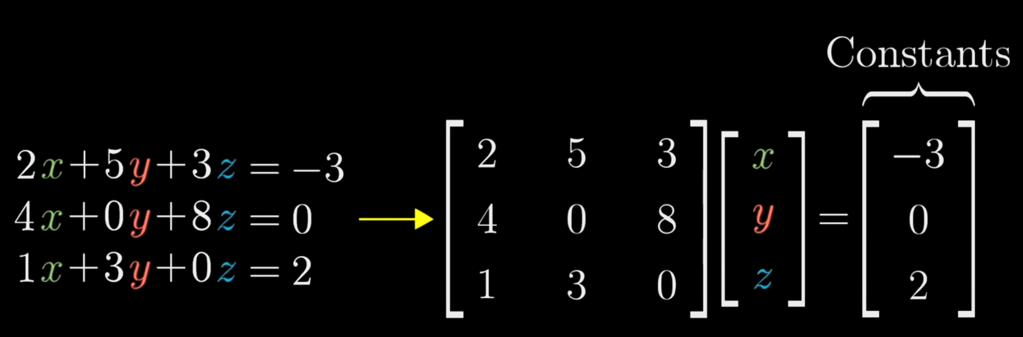

# Links

3Blue1brown Essence of LA Playlist – **Must Watch** -

https://www.youtube.com/watch?v=fNk_zzaMoSs&list=PLZHQObOWTQDPD3MizzM2xVFitgF8hE_ab

# Vectors

What is a Vector? The plain explanation would be that a vector is an ordered list of numbers.

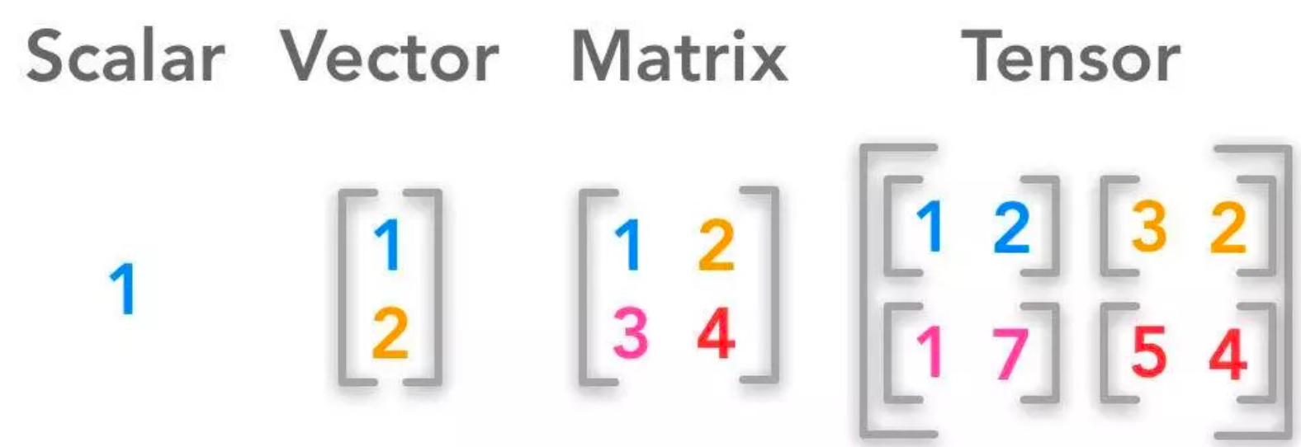

## 1 X 2 Matrix

**Do note:** a **1X2 structure is a matrix** aka row vector. That said row vector is still a Matrix.

A 1X2 structure like 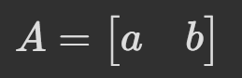 is a matrix. Period!!  
  
even if you transpose a normal vector, it still ends up as a row vector and a matrix.

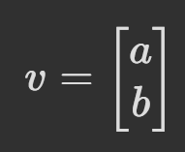 **=>** 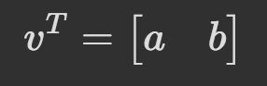

* Do not confuse with Arrays that are used in Python. Do note that sometimes theory explaining LA could suddenly shift to Python saying how it is implemented in Python which could be using an array but all said, you are no longer in Linear Algebra but Python WORLD. It can be confusing when we are thinking in Linear Algebra but when applied in Python we don’t follow certain rules of orientation.

**Notations**

|  |  |
| --- | --- |
| Vector notation: | Matrix Notation: |
|  |  |

## **Vector? Column or Row**

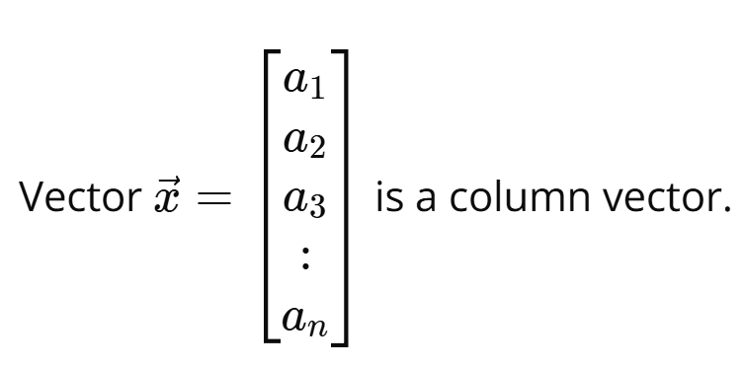 By DEFAULT should be Column vector. LA expects it to be a column.

1. Each row in a COLUMN vector represents the position in each dimension. In geometric sense, it is x, y z...etc dimension value. In ML it could be grades, gender, income etc.
2. Even in a matrix, a vector is vertical and each column represents different vectors

**?????**  That said, you can represent  as a row but it is Transposed version. If x is the column vector then the row vector is Transposed x and not x.

## Vector? Arrow or point

If you are thinking about an individual vector, think arrow but if thinking of multiple vectors and they inter-relations etc, then think point

**Vectors in Physics/Math**

|  |  |
| --- | --- |
| This is a vector in Physics:  vector | A vector has **magnitude** (size) and **direction**: The length of the line shows its magnitude and the arrowhead points in the direction.  Vector in Physics could be moved around while we will be using the Math version |

**Vectors in Linear Algebra (AI): Math Version**

* Vector **is as if** always grounded in the origin.
* The negative values and its placement in the quadrant thus also help in indicating the direction of the vector.
* That said, you will see some vectors being moved or vector soon starting at end of another vector, these are purely for visualizing the change in a different dimension and to visualize the final vector which is sum of two other vectors

|  |  |
| --- | --- |
|  |  |
| Vectors in LA stay in Origin | Movement away from origin is for visualization sake only |
|  |  |
| Original vectors as they sld be visualized | Move them out of origin just to visualize how a linear combination of the 3 gives us the 4th Green vector. |

### NOT COORDINATES but MOVEMENT:

1. 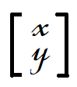 x,y here are **not** **coordinates** from origin but the translation along that dimension.   
   The square brackets with the numbers of each dimension in separate row is the differentiation from other forms of coordinates.
   * ( x , y ) with curved brackets is a point in the coordinate system and not a vector

### Basis Vectors:

Set of Linearly Independent vectors that span the given full space. So if two 2D then 2 basis vectors and 3 if 3D.

**j or y**

**i or x**

i and j or x and y are commonly used to represent unit vectors and comes up in different forms

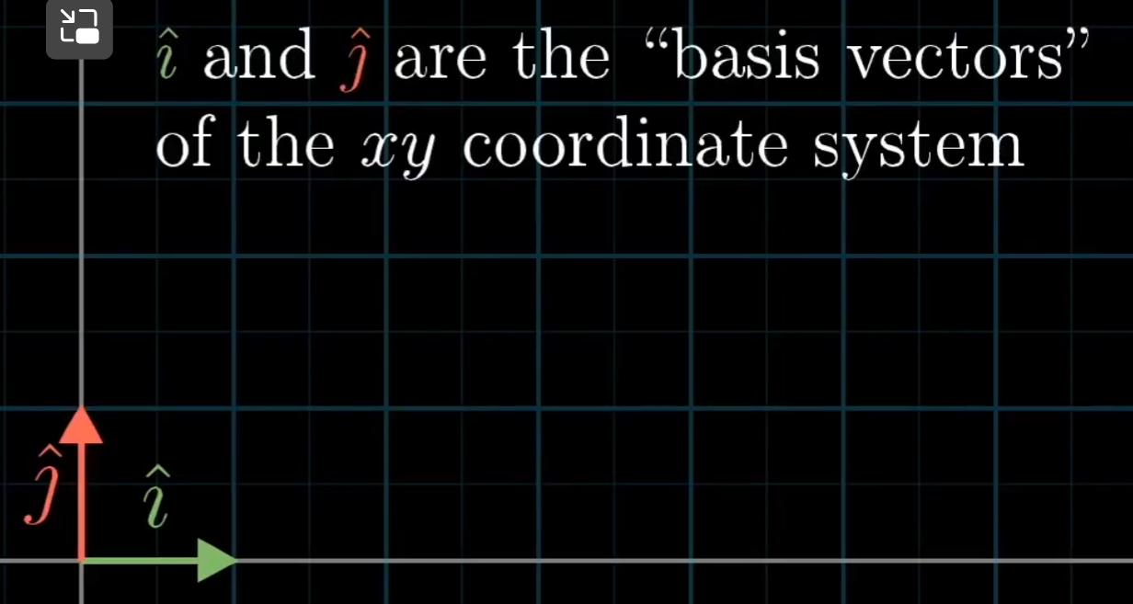

Any other vector are actually a scaled version of these Basis vectors.

### Vector Addition/Subtraction (numeral) :

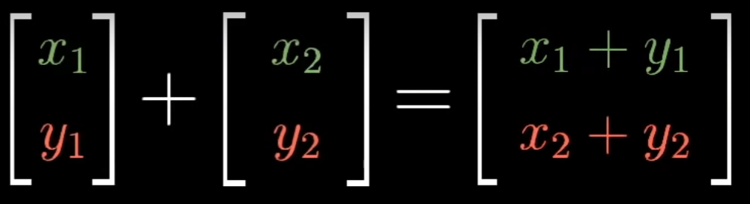

Requirement: A is **1 X 4 B is 4 X 3**

The matrices can be of different shapes but the no. of cols of A must match no. of rows of B. The resultant matrix will be of shape **1** X **3**

**Vector Addition Visually:**

|  |  |
| --- | --- |
| Vector Addition | Subtraction |
| P  P + Q  Q | Subtraction should be thought of like P + (-Q)  Q  P  P + Q  -Q  P + (-Q) |
|  | P – Q feels like it should be smaller line of P + Q but its not. P – Q is just in opposite direction of same magnitude  – opposing force of same magnitude and not necessarily smaller/lesser force |

|  |
| --- |
| Q  P  P - Q  P + Q  -Q |

### Vector Scalar Multiplication

Scalar is a single number that “scales” a vector. “Scalar” is just another word for multiplier.

|  |  |  |
| --- | --- | --- |
|  |  |  |

* From Visualization perspective, imagine the vector magnitude also changed ot multiplied by 2.
* Multiplying by negative is changing to opposite direction

### Vector Multiplication visualization:

|  |
| --- |
| Say 2 vectors P = 1 and Q = 2 ; P is multiplied by Q. R makes angle θ2 with horizontal.  P * Q  θ2  Q  P  θ1 + θ2  θ2  **θ1**  =  New vector R is P*Q (1 X 2) in size |

**Some Topics That digress a bit – Skip if not needed:**

**Magnitude and Direction**

Magnitude of vector is calculated using Pythagoras Theorem.

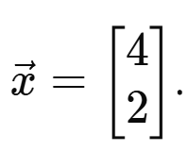 **=>** 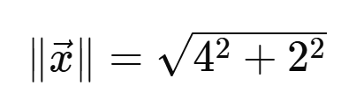

### Span:

Set of all linear combinations of vectors in question. Span help talk or represent possible values that one of many vectors together can represent. Eg:

* If the two or x vectors are all on one same line then the span is that one line extended to infinity.
* Another one is, if we have only 2 vectors in a 3D space, then the span (linear combinations only) of these two are only values in a single plane. Do note: NonLinear combination will allow the vectors to go beyond one plane of values.
* If the vectors in question have some angle between them , then their linear combinations set, aka span is all the points in the x-y plane
* In case of 3 vectors, if two of them are on the same span (aka those are said to be **“Linearly Dependent”**) then the span of all 3 are still only a plane and not all possible values in 3D space. Example Application in Real world: in an ML experiment we notice that of the 3 input vectors, two of them are in same span, then we know that that span is a 2D plane.
* **“Linearly Dependent”:** When two are more vectors end up on the same span which in some cases can allow us to remove them since they are not adding value.   
  When one vector **can** be defined as a linear combination of the other vectors, they are a set of **linearly dependent** vectors.
* **“Linearly InDependent”:** When each vector really add another dimension.  
  When each vector in a set of vectors vector **can not** be defined as a linear combination of the other vectors, they are a set of **linearly independent** vectors.   
  The easiest way to know if a set of vectors is linear dependent or not, is with the use of **determinants**. Finding Determinants will tell you about this relationship although out of scope in this discussion.

### Linear Dependence:

Given [a] and [b] are vectors in the X-Y plane

If one vector [a] can be represented by a different linear combination of another vector C1 [b] then they are linearly dependent. Another definition, consider two or three vectors and the span on each. If the vectors are such that even removing the vector does not affect the span of all of the vectors, then they are linearly dependent. Linearly dependent vectors do not change the span of each other. Eg: lines in x-y plane (except those that are in a same line or point) are linearly dependent since each of them have the entire x-y plane as span

### Linear Independence:

Now say [p] is a vector in z plane/dimension then this vector cannot be represented in any way using vectors [a] or [b]. This is called linear independence. Basically, if a vector changes the span of another vector then they are lin. Independent.

### Linear Combination

Linear combination is a name given to way of combining two vectors such that the resultant vector satisfies certain conditions like being in the same dimensions as the originals.   
So basically, a type of combination that keeps everyone /vector in the same dimension and not include a new 3rd dimension or higher.

* It just implies whats happening to the vectors and also whats not happening like being moved into a another dimension.
* It is also a way if applied over and over allows the span to the determined as in what is the span of a set of vectors. This is purely an application and benefit of doing this and not a property of Linear combination.

Vector transformations that involve only vector additions and scalar multiplication are called Linear Combination.

* Scaler Multi and vector additions alone are called Linear combination because of few properties they adhere to.
  + they preserve the fundamental properties of vector spaces - specifically linearity
  + They preserve the dimensions – 2 dimensional elements undergoing a linear combination remain 2 dimensional
    - While say dot product returns a scalar value or cross product that creates a new vector perpendicular to both input vector
  + Scaling is done uniformly across all dimensions
  + The direction change is only full 180o or reverse
  + The proportional differences between components remain undisturbed
  + The Linear combination action addition allows two vectors the freedom to become any other vector after combination. Which allows Math / AI system to represent anything without any restrictions. By the SPAN of two vectors is list of all possible linear combinations of the two.

### Linear Transformation

Linear Transformation is an function / action in LA that changes a vector into a new vector linearly (as in no squishing /curving the vector which is non-linear).

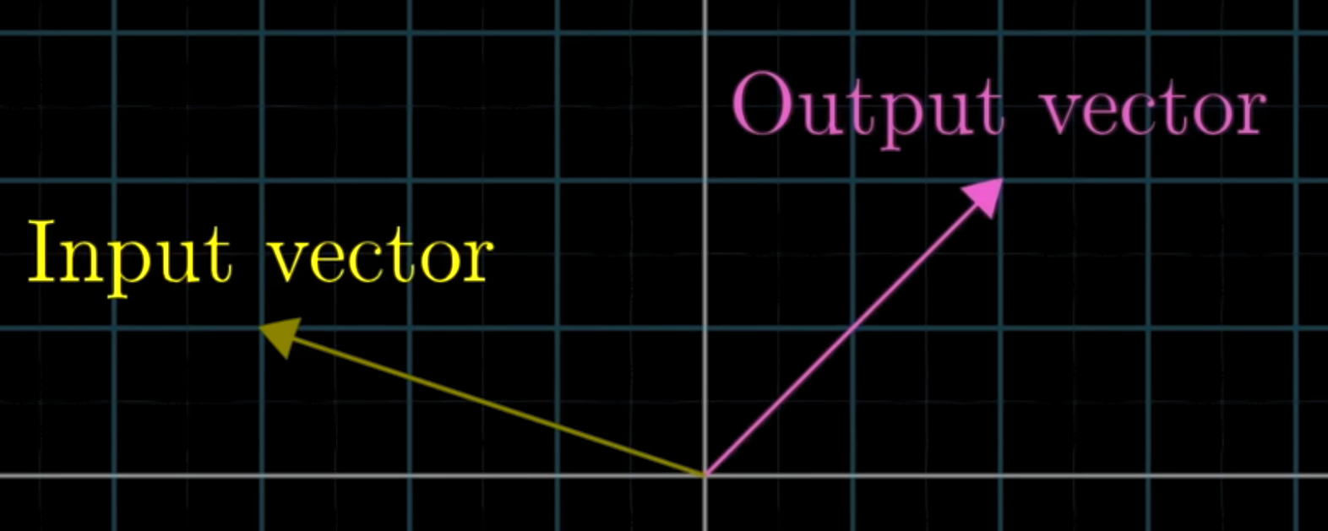

#### Conditions for Linear Transformation

Purpose for conditions: 1) A vector as input returns another vector instead say a scalar or change in dimensions.   
  
Linear: Transformation must remain Linear as in:

<https://www.youtube.com/watch?v=kYB8IZa5AuE> (watch this for visualization)

* Lines should remain lines without any curving (which happens if non-linear action is involved)
* Origin Must stay fixed at 0,0 even after the transformation
* All said, if the gridlines (same action on just basis vectors) are kept parallel and equally spaced, Linear conditions should be satisfied.

IMPORTANT:

To translate the transformation to all points / vectors involved, we must focus on only what happens to the basis vectors.

|  |  |
| --- | --- |
|  |  |
| * When a given transformation is applied, we see where the basis vectors i and j end up. * i ends up in [1, -2] and j ends up in [3, 0] now take these numbers and multiply with the all the involved vectors * Imagine [ x , y ] represent all the vectors in question then we apply it like below and voila all the vectors are transformed. This matrix multi-plication is what is happening in ML and how a vectors get changed. | |

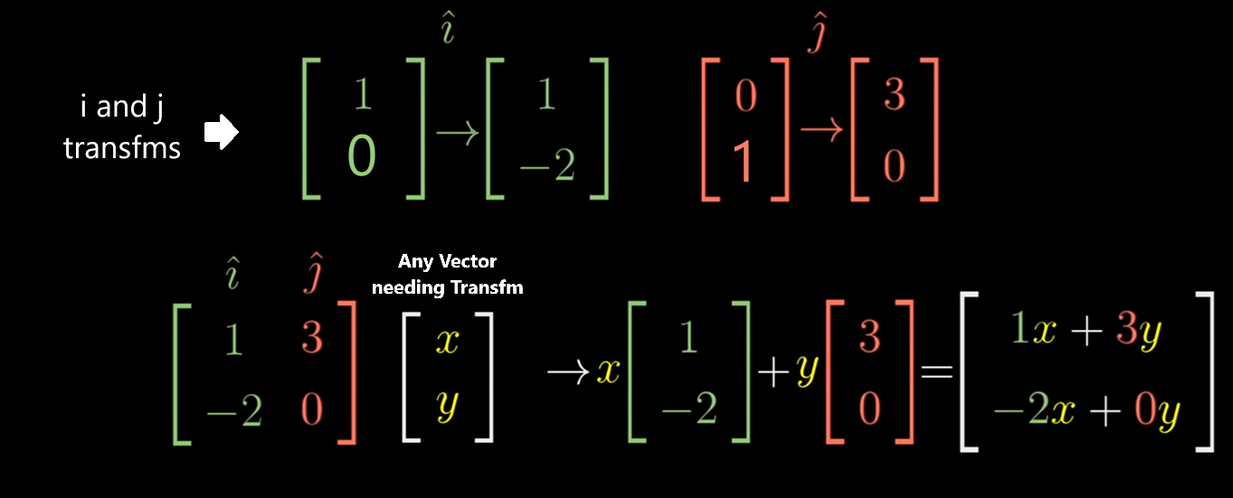

#### Linear Transformation Flow:

**Below Example in 2D vector space:**

**1: All components:**

1. Transformation matrix : which are are transformed Basis Vectors
   * All you need for any Transformation is know what happens in the end to basis vector .i and j in form of a matrix. Column 1 is the transformed .i basis vector and column 2 is transformed j basis vector.

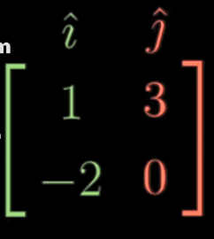

1. Target Vector v (or could be matrix):



1. Matrix multiplication is not Commutative : AM ≠ MA so order matters. It is T X v

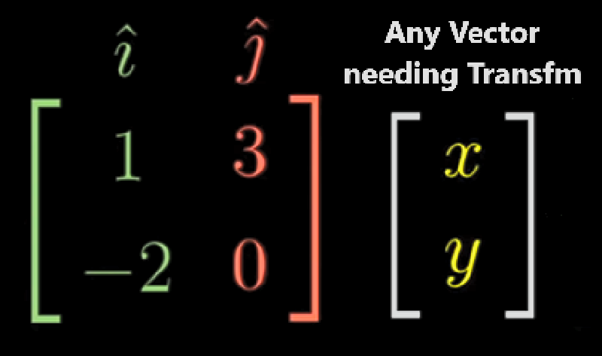

**2: Matrix Multiplication:**

Apply the transformation on the target vector thro matrix multiplication.

It also happens to be be a Linear combination of the transformed basis vectors moderated or influenced by our target vector actually ends up be the resultant new vector.

#### **Linear combination vs Linear Transformation**

A linear combination *of vectors* is the result of adding up scalar multiples of those vectors; it's not a function

A linear transformation is a function from a vector space to a vector space that is additive and homogeneous.

* linear transformation is the linear combination of transformed basis vectors

# **Matrix**:

Matrix **Addition**: Add each corresponding elements. The matrices must have identical shape.

## **Matrix Multiplication:**

TLDR: Matrix Multiplication, the way it is done, should eventually mean that we are combining transformations together.

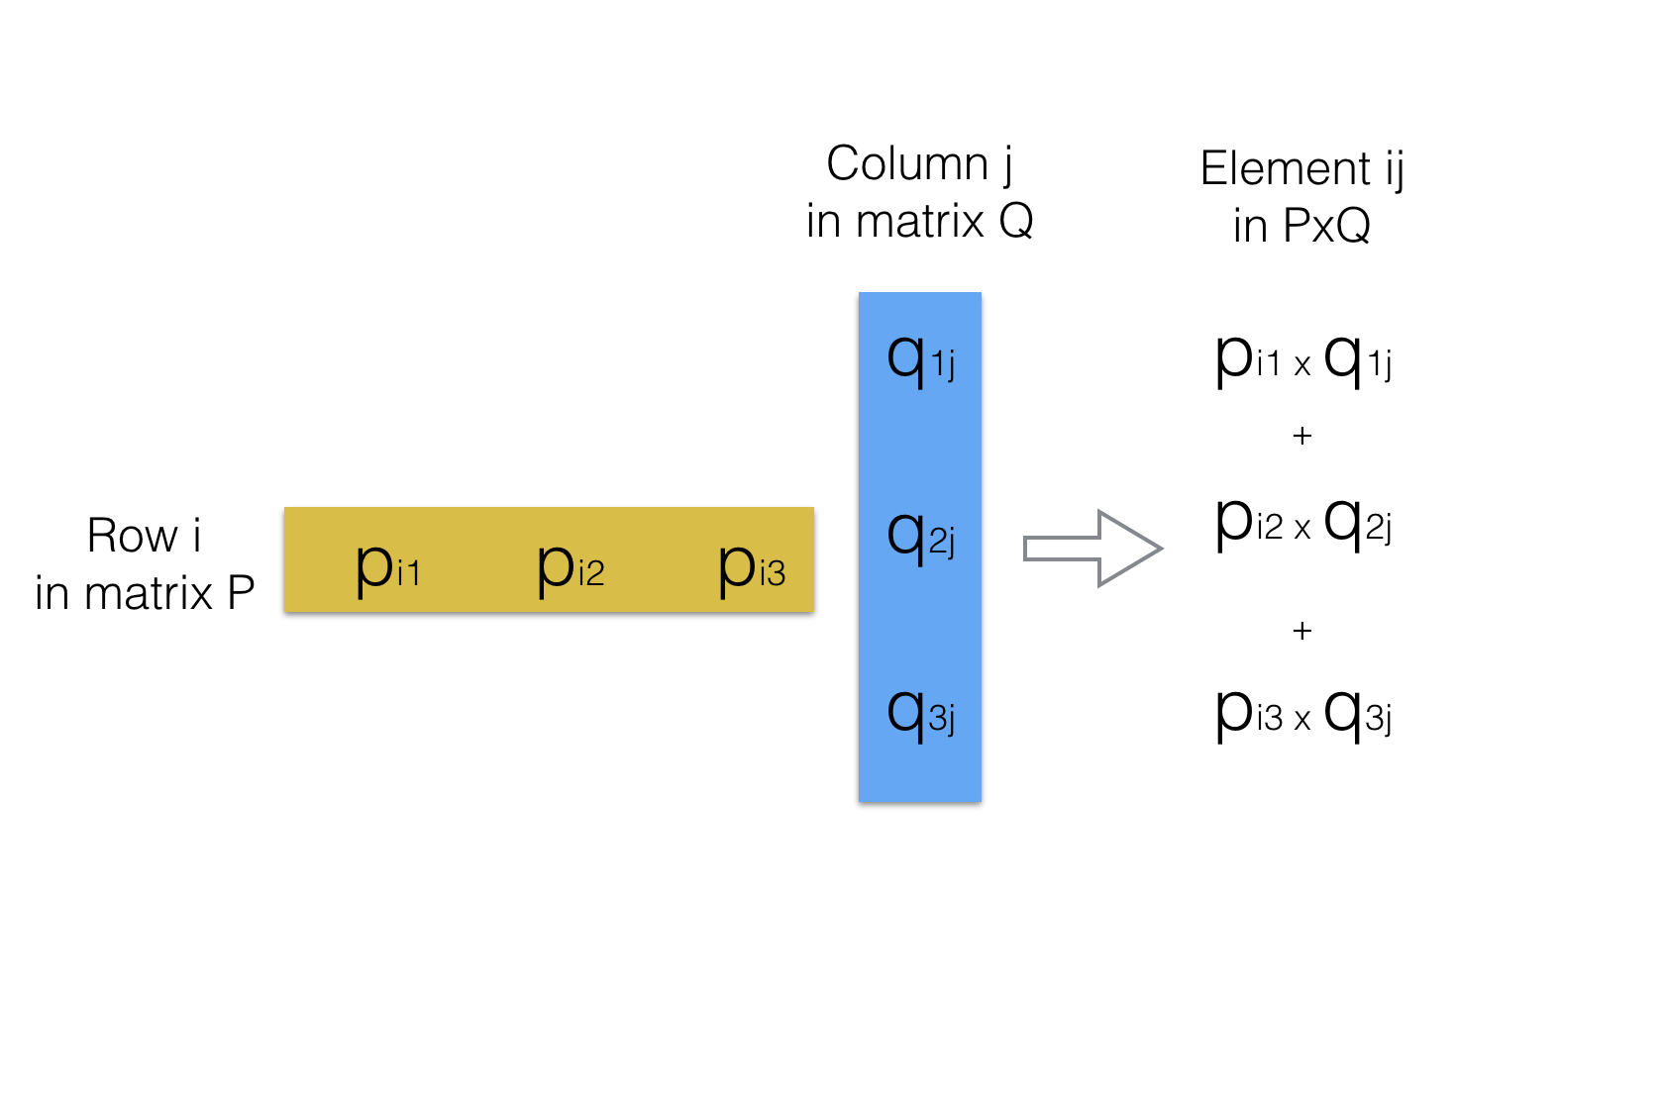

**Why row into column?**

Simply put it simply allows us to know what it does to a given vector and allows to visually see if in 2D / 3D space.

This approach preserves the "composition of linear transformations". Dont fully understand it yet. <https://www.youtube.com/watch?v=XkY2DOUCWMU&list=PLZHQObOWTQDPD3MizzM2xVFitgF8hE_ab&index=4>

“Matrix multiplication is defined the way it does because it then coincides with composition of linear transformations. There are other matrix multiplications (e.g., the Kronecker product, which is entry-by-entry), but the great advantage of the "usual" matrix multiplication is that it corresponds to composition of linear transformations. “

What is composition of linear transformations? If there are two transformations A and B which can be applied one after another. Instead, if you do the Matrix multiplication way of A and B, then the resulting “Composition” matrix is same as if you had done the transformations of A and B separately one after another. This way of doing matrix multiplication in unintuitive way thus preserves composition of linear transformations.

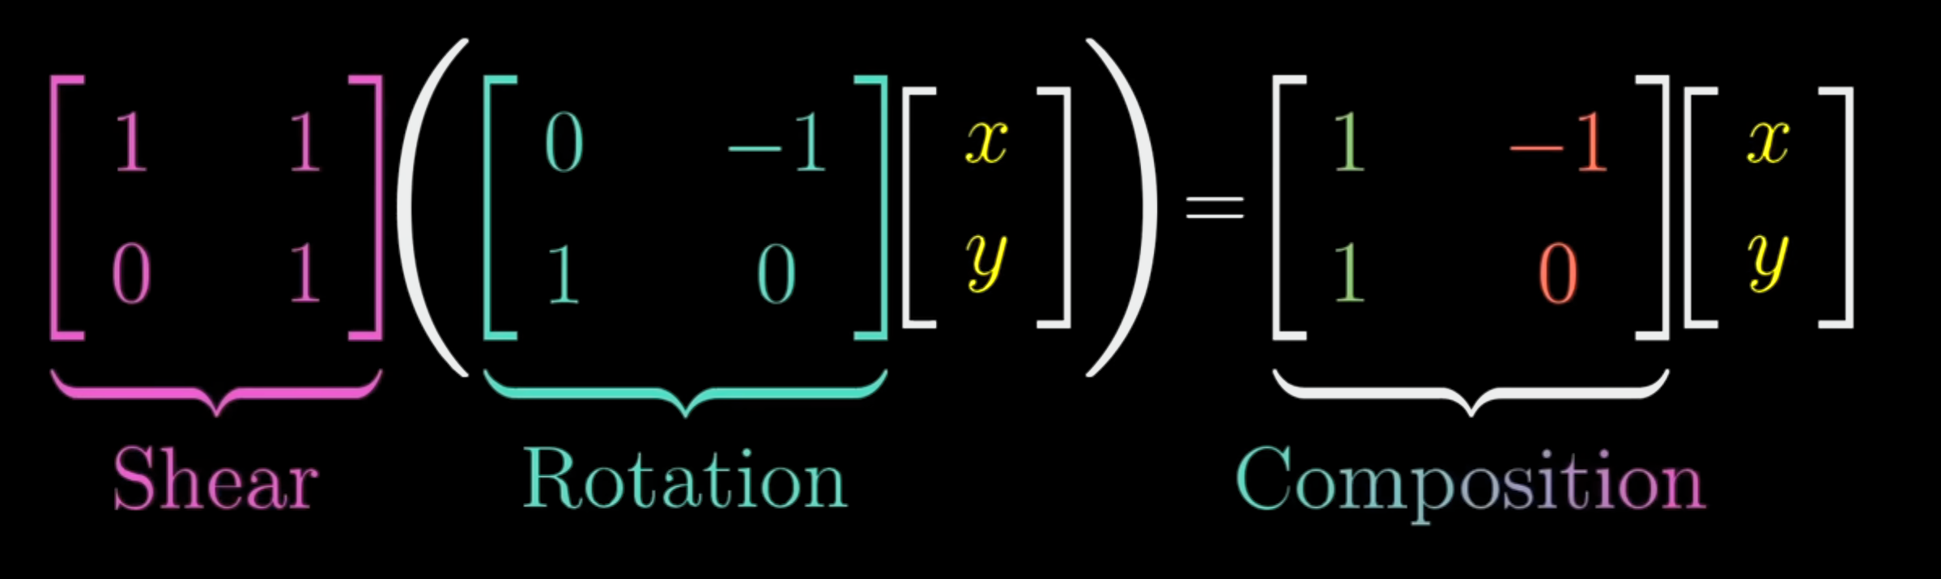

As above, composition is just one matrix applied instead of having to apply Rotation and Shear one after another.

<https://math.stackexchange.com/questions/24456/matrix-multiplication-interpreting-and-understanding-the-process>

<https://math.stackexchange.com/questions/1698783/understanding-matrix-multiplication>

Since this “preserves the composition of linear transformations" – which is basically combine multiple transformations into one matrix, the use of this in ML is so soooooo beneficial. This way by using Linear Algebra Matrices, **ML could in a way simultaneously do multiple transformations** in one go without having to worry about interaction of them of painfully do them one by one. You basically don’t need a factory to productionalize each modification needed but do it all at once.

**Combo Transformations and Order**:

If there are multiple transformations, they can each be multipled and only the final matrix be applied which will produce the resulting vector which will be same as doing each one at a time.

That said, when applying multi

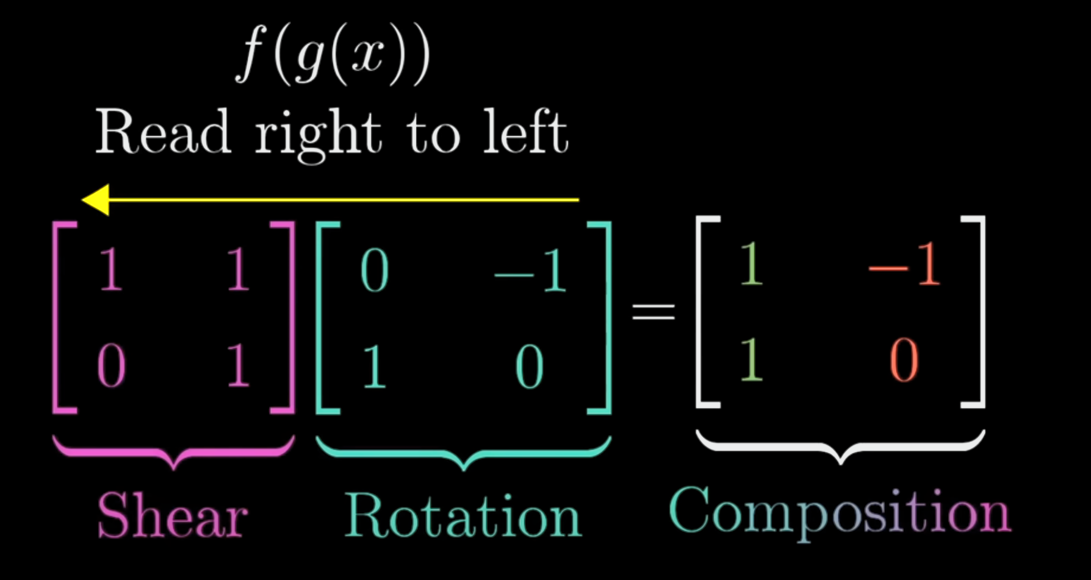

**2X2 * 1X2**

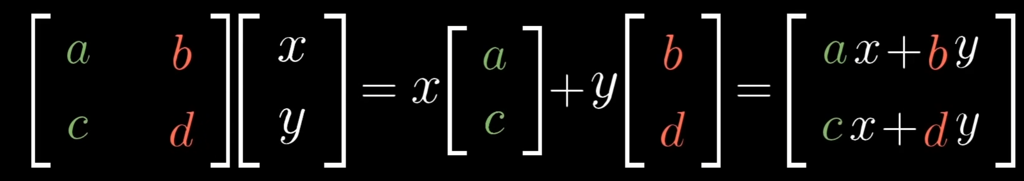

**2X2 * 2X2**

|  |  |  |
| --- | --- | --- |
|  |  |  |
|  |  |  |
|  |  |  |

**Matrix Multiplication Properties:**

**Not commutative**: Changing the order of transformations changes the output

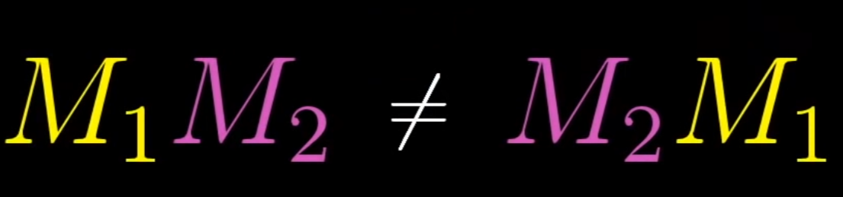

**IS Associative**: Below, there is no change in order as in AB is not made BA as long as this is good, it is associative. So you can put multiple and just ensure that AB does not become BA in the order.



## Vector/ Matrix orientation

When should a vector be processed a column or a row?

Should the weights being applied on the input vector be aligned as rows or columns?

The answer is it depends on the situation – basically a dynamic question.

First, **Matrix multiplication and Addition Rules**

* Multiplication: Column to Row elements are first multiplied and added to get a summation / cumulative value
  + For A×B to be valid, the number of columns in A must equal the number of rows in B
  + Result will have same number of rows as A and same number of columns as B
  + If applying weights on single or multiple vectors in a matrix, the orientation should fit
    - Consider a mini-batch of N size of input data points / vectors and has d features. Each sample is a row hence N X d matrix. Now we have weights for each of these d dimensions. Hence the Weights matrix is d X O (O for output). O is dependent on the expected output or aka number of neurons receiving this output.
* Addition: Matrix addition is done element to corresponding element of second matrix
  + If you are applying a bias which involves element wise addition then it is a column vector.

Second, **What is expected as Output**?

* A single value (scalar) or
* A vector (one per sample)
* A probability distribution
* Similarity matrix like in Attention mechanism (in this case we transpose the Key matrix → Q.KT
* Eg:

**n**: Number of samples in the mini-batch.

* + **d**: Number of input features (or neurons in the current layer).
  + **m**: Number of output features (or neurons in the next layer).

For example, if you are training a neural network:

* Input layer has d=5 features per sample.
* The next layer has m=3 neurons (output features).  
  The weight matrix W would be of shape 3×5.

After multiplying X (shape n×5 ) with WT (shape 5×3), the output Y will have a shape of n×3, representing the transformed output for each sample in the batch.

**General Rules of the Matrix / vector orientation when representing and when applying in a formula:**

**Input Samples Representation**

* **Single sample:** Represented as a **column vector** with each feature stacked vertically (e.g., a sample with d features is a d×1 vector).
  + Example: A sample with three features could look like:

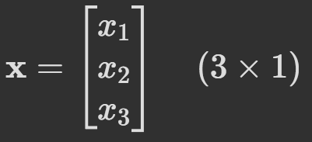

* **Mini-batch of nnn samples:** Instead of processing each sample separately, we stack all n samples as **row vectors in a matrix**. This results in a matrix of shape n×d, where:
  + Each row is one sample with d features.
  + Each column corresponds to a specific feature across all samples.

For n=3 samples, each with d=3 features:

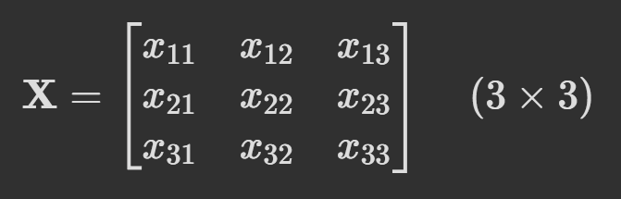

**Weight Matrix Representation**

* **Weights for transforming input:** The weight matrix W typically has dimensions o×d where:
  + d is the number of features in the input layer (matching input sample size).
  + o is the number of output neurons (or the number of features for the next layer).

For an output size o=2 and input size d=3, the weight matrix might look like:

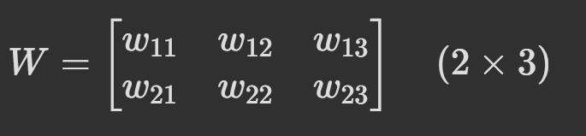

**Matrix Multiplication (Forward Pass)**

* To compute the output for a mini-batch: Y=XWT
  + **X:** Shape n×d (mini-batch of inputs).
  + **WT:** Shape d×o (weights transposed for correct alignment).
  + **Output Y:** Shape n×o, representing the output for each sample in the mini-batch.

### Matrix Multiplication Properties:

1) Transpose matrices relation

A and B are matrices then: (A . B)T = BT . AT

2) Scaling up and down dimensions

You can scale 2D dimensional item to 3D and reverse as well. Hence if you notice a Higher (Height) matrix like a 3X2 in a 2D space vectors, then 2D is being scaled up to 3D.

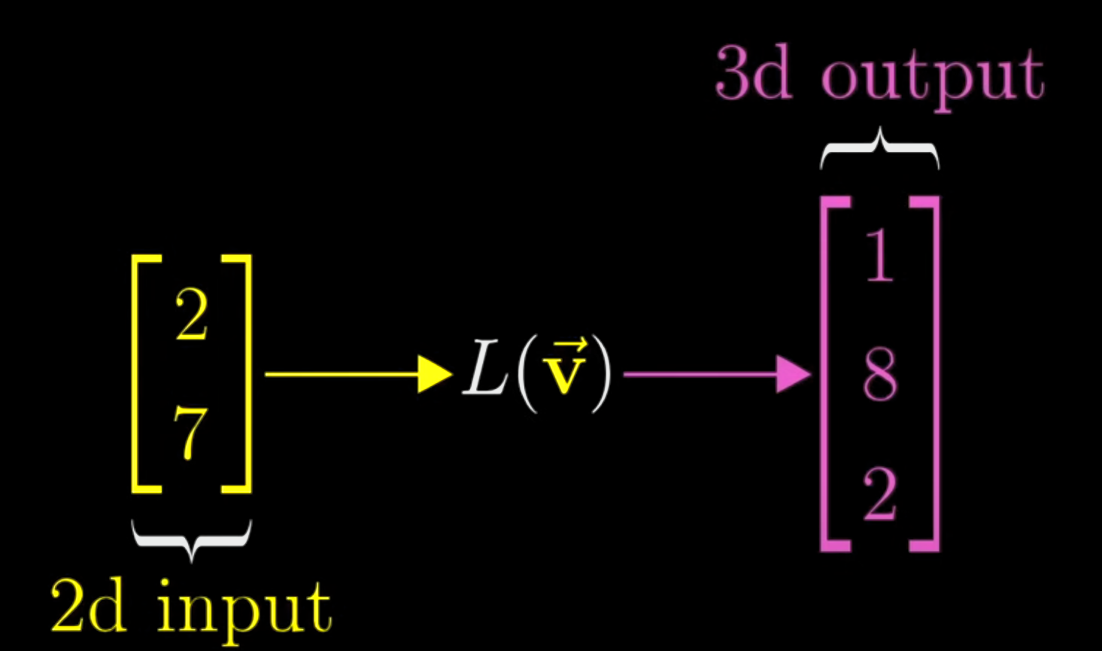

Sameway, 3D can be brought down to 2D with a longer / flatter matrix, 2X3 matrix

|  |  |  |
| --- | --- | --- |
|  |  |  |
|  | 2D to 3D trans matrix | 3D to 2D trans matrix |

## Dot Product

Dot product is another way of combining two vectors where the value quantifies a relationship between the two vectors. Matrix multiplication is way of combining two vectors/matrices such that one transforms another to give a new entity.

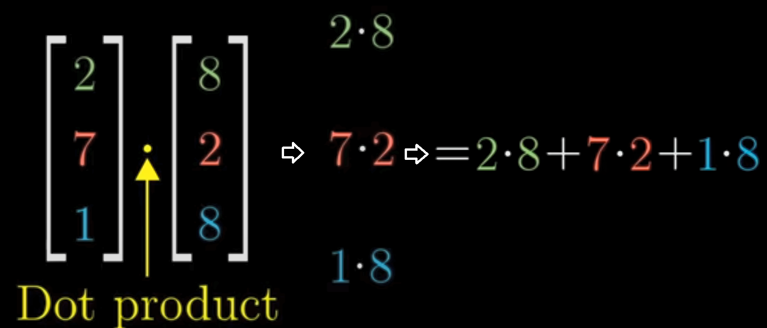

Whats important is that the scalar value obtained:

* Gives the similarity value
* Dot Product value > 0 or positive then the two vectors are similarity
* Dot Product value < 0 or negative then the two vectors are opposite and very disimilar
* Dot Product value = 0 then perpendicular

In Geometry, dot product formula between two vectors is

a⋅b=∥a∥∥b∥cosθ , θ is the angle between the two vectors.

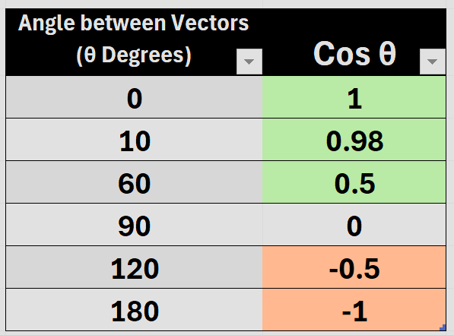

**Not so important Topics::::**

Projection of one on another:  
Dot Product is like multiplying one vector (yellow below) with the projection of other vector onto itself (pink arrow on yellow vector).

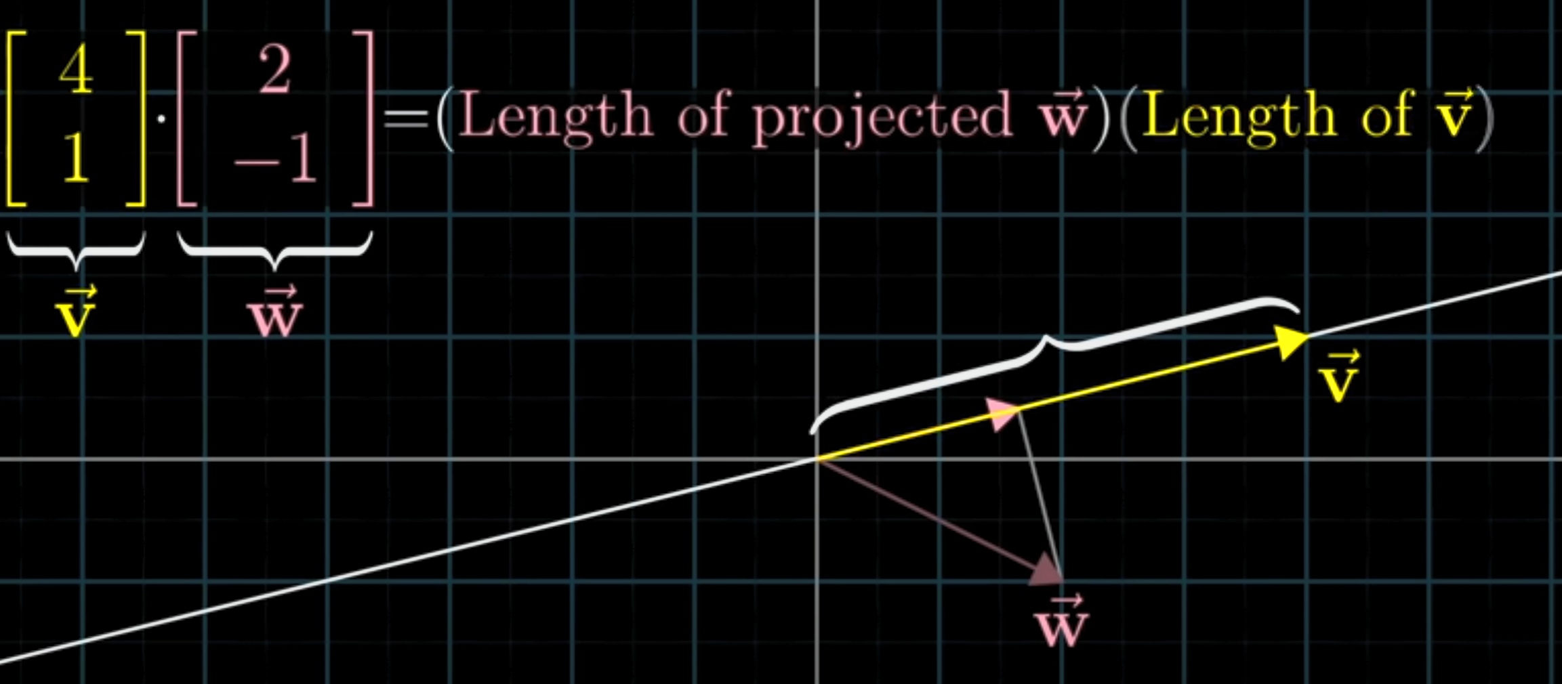

The projection part is actually very important in PCA and SVD. So dot product will get used in PCA and SVD but only to obtain the projection values

Duality in Dot Product

Dot product has two formulas one is Geometric and other in Algebraic

* a⋅b=∥a∥∥b∥cosθ
* a⋅b= a1b1 + a2b2 +⋯+ anbn
* θ geometrically tells if the vectors are similar or not
* algebraic form shows that they are like coefficients such that if many of the terms are negative then the two vectors are opposite and same time if each of the terms are more positive then similar. In algebraic, we can break down to see which dimension are dominating and pushing towards +ve or -ve

## Important term definitions:

## Inverse Matrix - Intuition

Inverse Transformation is basically 1/A in matrix sense and noted by A**-1** . Application wise it indicates reversing a transformation which can be easily done by finding the Inverse Matrix of the Transformation Matrix used.

A**-1** = Inverse of ( A )

* Inverse Matrix form is very powerful and needed in ML since it, if known can lead to quick calculation of solutions in many situations like solving Linear Systems (Lin. Regression eqn) itself. The catch is that matrix Inversion is computationally expensive and in the Order of O(n**3**).
* Inversion are so compute heavy that many ML Models avoid explicit inversion by using iterative methods like Gradient Descent
* Matrix inversion can be obtained by few techniques: **Gaussian elimination, LU decomposition, or SVD**

Now a property of the inverse matrix dot product:

A**-1.** A = [ 1 ] Identity Matrix since this does nothing.

In 2D space: 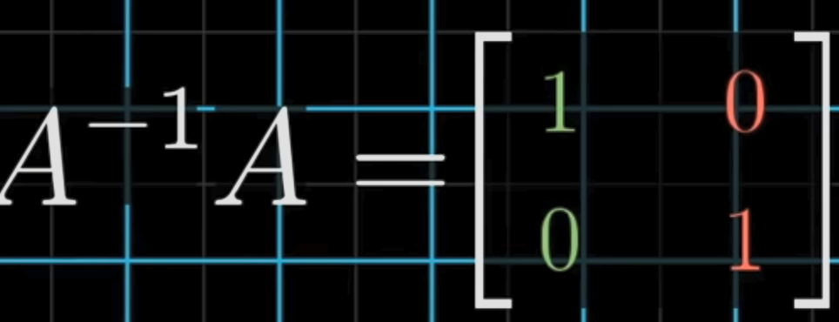 or in 3D: 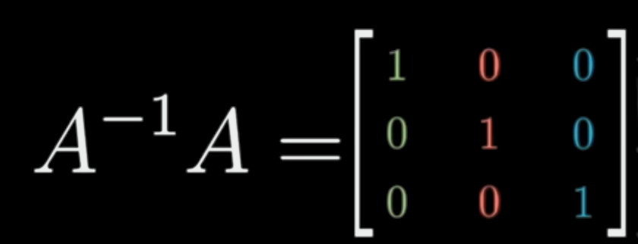

* As long as det(A) ≠ 0 then A**-1** exists.
  + If det(A) = 0, it means that the transformation squished one of the axis or dimension to 0 and thus is lost forever and this cannot be undone. There are edge cases when you can inverse. Just fyi

### Non- Invertible Matrix

Matrix cannot be inverted if:

1. is Non-square
2. Determinant is zero (area of vectors defining vector is zero in 2D case or zero volume in 3D case). Det ( A ) = 0

### Pseudo - Inverse Matrix

Pseudo- Inversion is a technique used to invert a non-invertible matrix using a Moore-Penrose technique which is generalization of a full-on inversion.

Pseudo- Inversion can be applied to non-square matrix and singular matrices.

* Pseudo- Inverted matrix are indicated as A**+**
* Pseudo- Inversion technique has lower time complexity O(mn2) than normal inversion O(n3) thus this is preferred.
* Using Pseudo-inverted matrix is so beneficial that it is sometimes used in default in certain Linear Regression solutions eqns.
  + It is pain to keep checking if the matrices are square or non-singular hence by default Pseudo-Inverted matrices are used for Stability in algos not mention the computational overhead reduction from O(n3) to O(mn2).

### Column Space

C**olumn space** of a matrix is just **the span of its only its columns. Span refers to all vectors while Column Space simply isolates the span of only the vectors in one matrix.**

**Why is Column Space treated separately:**

**1) To understand / converse about the Feasibility of Solutions   
Column Space tells if a system of equations has a solution. If a target vector b is outside the column space of A, then the equation Ax=b has no exact solution.  
The issue on everyone’s mind is that is solution within the span of the vectors that are going into the eqn. Column Space term explains this and so constantly used.  
  
 Term/ Space is used a lot in regression, feature selection, and PCA**

### ****Rank****

**The rank of a matrix A is the dimension of its column space, meaning the number of linearly independent columns.**

**Key Points:**

* **Full Rank**: If rank = min(rows, cols), the matrix has **linearly independent columns** (useful in ML).
  + Full Rank is also used a lot to announce that there arent any dependent columns.
* **Low Rank**: Some columns are **dependent**, meaning redundant information.
* **Rank & Solutions**:
  + If Ax=b has a solution, b must be in **column space**.
  + **Overdetermined** (m>n) → No exact solution (use **least squares**).
  + **Underdetermined** (m<n) → Infinitely many solutions (use **pseudo-inverse**).
* Rank Examples: Rank of a line is 1 since it is 1D. Rank of a plane is 2 → 2D, 3D object willhave Rank 3

### System of Equations:

System of Equation describes a situation when we have linear equations with unknowns variable which we seek to solve and made known. The linear equations are solvable if certain relationships between them are known.

* Eqn in question must be linear without any non-linear terms in them like x2
* If all comply, then we can solve them by different ways like graphically (if two lines eqns then see where they intersect), or by substitution or elimination as done in school algebra classes.
* System of eqns can also be represented and solved with matrices / Linear algebraic

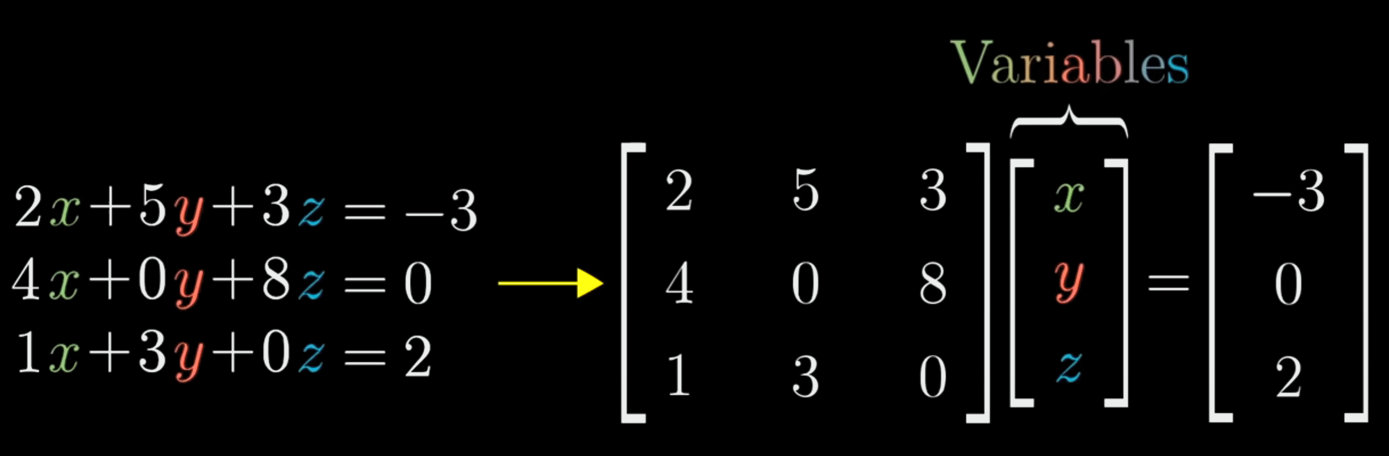

### Determinant of a Matrix – Intuition

Determinant of a transformation matrix tells us how much area (in2D system) that transformation is going to change. In 3D system, it tells how much volume changes with a specific transformation matrix.

Not used in ML – non graphic cases much.

### Non Square Matrices

In 2D space, if you see a 3 X 2 matrix then there seems to upscaling from 2D space to 3D space.

|  |  |
| --- | --- |
|  |  |
| When everything is 2D and then u see the transformation matrix has a 3rd row of elements indicate that .i and j seem to have x, y and z coordinate hence a 3rd dimension is being included | When everything is 3D and then you see a 3X2 matrix, it means we are squishing things to 2D space. |

## Basis - Advanced:

Span minus redundant vectors becomes a “basis for”

A basis is a set of linearly independent vectors that span some vector space.

In general, if a set of vectors is linearly independent it's called a basis for the span of these vectors. That's all.

Edit: Let's clarify some common phrases. A basis is always a basis for ... In that sense a set of linear independent vectors is a basis for the span of that set of vectors.

“Basis” is a characteristic of vector space in question. “Basis” are vectors that are linearly independent to each other and thus together they give access to the full/max possible span of the vector space in question. Eg: if the vector space is x-y plane then i and j unit vectors can be the “basis” or basis vectors. Because with i (representing x axis) and j (y axis) all the points in the x-y plane can be reached.

AKA:

* **Basis is the linear independent subset of columns of a matrix such that it has the same span as original matrix. Basis for column/row space are the vectors from original column/row space and not the reduced form ones.**

Basis is not unique. Basis is a spanning set but does not have redundant vectors.

### Basis Advanced Topics

#### Standard Basis:

Normalized basis is standard basis.

Since normalized they are unit vectors and noted as e.

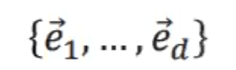  
Standard basis properties:

1. Unit vectors
2. Orthogonal
3. Axis aligned

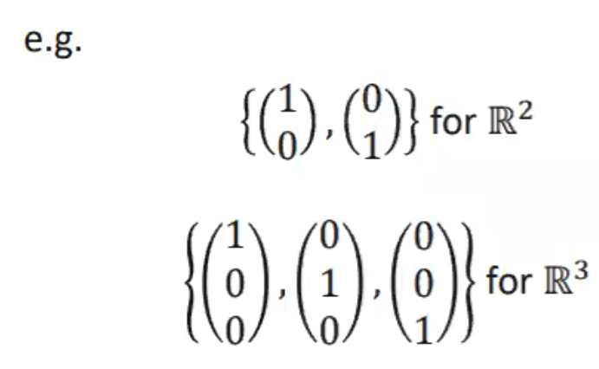

#### Orthonormal Basis:

A standard basis which is not aligned to axis is simply called orthonormal basis.

Orthonormal = unit vectors and orthogonal to each other.

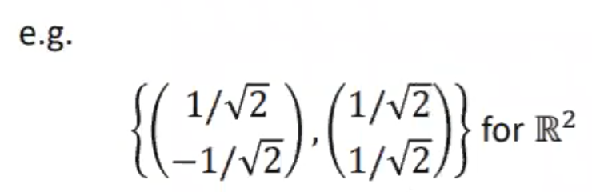

## Changing the “Basis”

If the basis vectors get changed, a vector in the new vector space is found by finding the scalar projection of the vector with each axis.

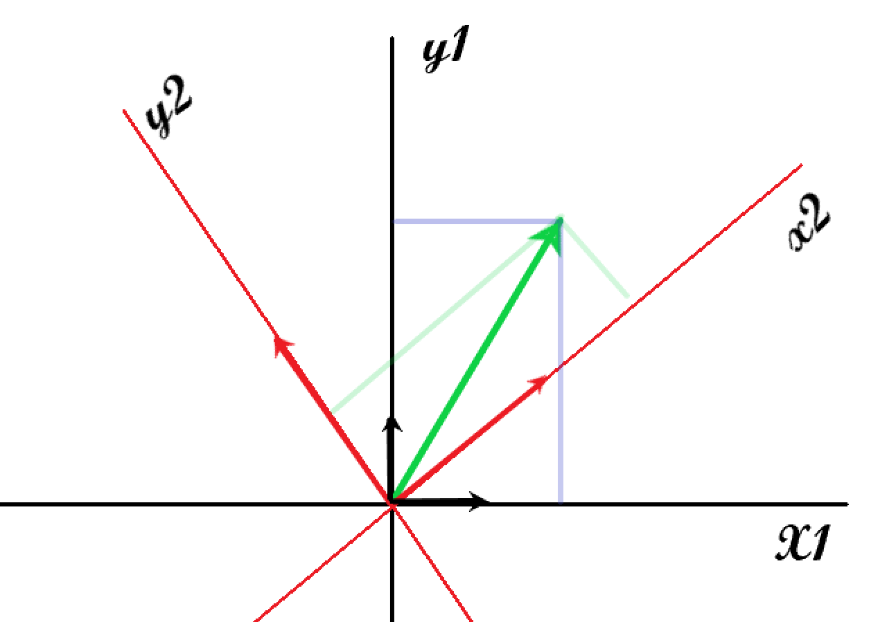

old axis x1-y1, basis vectors = (0,1) and (1,0)

Vector (green) V = (i1,j1) i1 and j1 are the scalar projections on unit vectors (0,1) and (1,0)

New axis (red):, basis vectors (thick red) = (-2,4) (2,1)

Vector V in new axis is defined differently since basis changed.

For new basis, find the scalar projections of the vector on new basis vectors, which gives (i2,j2)

(i2,j2) can be found if the new basis vectors are known from old unit vector basis.

Eg: Red -> New space coordinates **Blue** -> Old space coordinates

1. When new basis vectors are **not** orthogonal:

Given vector defined in new space. **Basis vectors** of new space in old space given.

1. **New Basis vector matrix** in old space terms * Vector = **Vector (**in old space terms)
2. Inverse of **Basis vector matrix** gives **old basis vector matrix (**in new space terms)
3. **Old basis vector matrix * Vector = Vector (** in new space)
4. When new basis vectors are orthogonal:  
   When orthogonal, simple projections can be found quickly

Finding vector as defined in new space / (aka finding projection of vector on new basic vector):

1. Find projection of old vector on each of the two new basis vectors/axis:  
   **Old vector** .(dot) **New basis vector** in old terms = one of the vector terms in new space terms
2. Repeat above with the second basis vector to get the second term of vector

… refer to notes on notebook

Einstein's Summation Convention

Einstein summation convention, in which we sum over any indices which are repeated. In traditional notation we might write, for example, ∑*j*=1 3​*Aij*​*vj*​ = *Ai*1​*v*1​+*Ai*2​*v*2​+*Ai*3​*v*3​. With the Einstein summation convention we can avoid the big sigma and write this as *Aij*​*vj*​. We know that we sum over j because it appears twice.

### Projections:

### Scalar Projection:

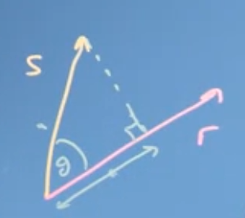

cos θ = adjacent / hypotenuse

Hypotenuse = |S| and adjacent aka “projection” (of S on R)

=> hypotenuse * cos θ = projection or projection = |S| * cos θ

Applying this in Cosine rule: R.S = |R|*|S|*cosθ => R.S = |R|*projection => R.S / |R| = projection aka scalar projection

Scalar projection of R on S = R . S / |R|

Scalar projection does not have direction and so no arrow tip.

Scalar projection formulae to remember:

(Geometric formula) Scalar projection of A↓B **= |A| * cos θ**

(Algebraic formula) Scalar projection of A↓B = **AdotB / |B|**

Vector projection:

Vector projection is a vector (x,y) basically scalar projection with direction. To get it:

Vector projection of A↓B = **Scalar projection * B / |B|**

= **AdotB * B / |B|2**

**= AdotB * B / BdotB**

Besides, Magnitude of the vector projection is the scalar projection

Orthogonal Projection:

A vector can be defined by two perpendicular vectors (one to represent x and another for y).

u = w1 + w2. W1 is the

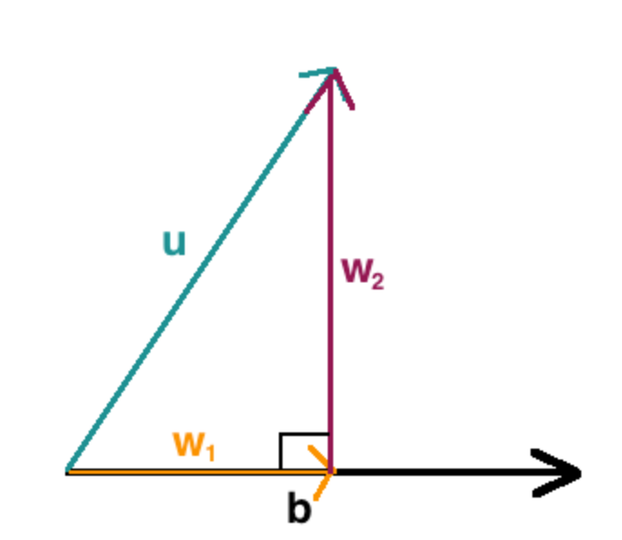

This can also be referred to a decomposition of vector. (decomposing vector to vectors).

|  |  |
| --- | --- |
|  |  |
| What is O. projection all abt?  u and v are already known. O.projection is about finding this “scaling” number which once found can be used on u and projection found. This concept is repeatedly used in Linear algebra.  In fact in linear regression, the coefficient matrices are the “scaling” that needs to be found. | |

Residual Projection.

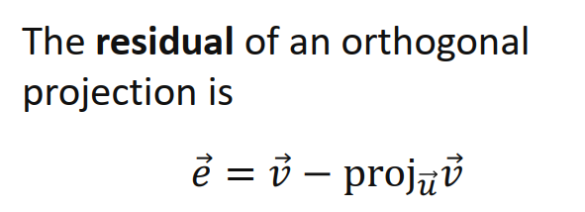 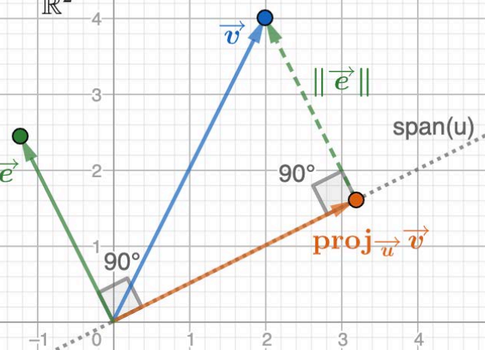

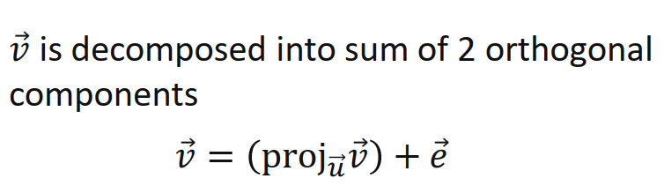

The decomposed vector form is actually regression formula where v is y and projuv is the coefficient and e is the error.

## Orthogonality and Orthonormality:

<https://www.youtube.com/watch?v=6nqMegdbxik>

Vectors perpendicular to each other are called orthogonal vectors. This characteristic is very important/fundamental for many other benefits.

Test of orthogonality:

A.B = 0 (cos 90 = 0 in |a||b|cos90 formula)

Orthonormal are orthogonal unit vectors.

Orthonormal = orthogonal + length 1

Eg:

With Orthogonal vectors,

AT = A-1

Transpose is equal to the inverse

Thus A AT = Identity matrix

### Gram-Schmidt Orthogonalization process:

<https://www.youtube.com/watch?v=zHbfZWZJTGc>

In above video, if the b vector is a unit vector then

Process converts a set of vectors to an orthogonal set. It is usually further normalized to create a orthonormal set.

# Inverted Matrix

Inverted matrix is of A is 1/A or A-1

### Matrix Invertibility Criteria:

If one of below is true all are true and same if one is false all is false.

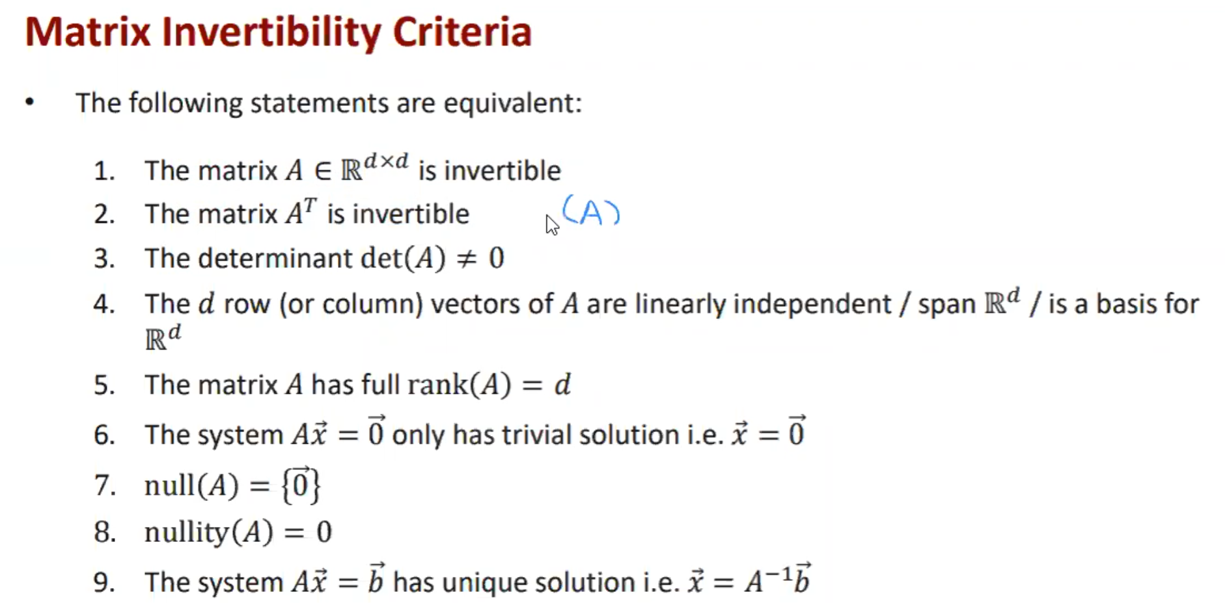

How to find inverted matrix:

## Gauss-Jordan Method:

Given A: 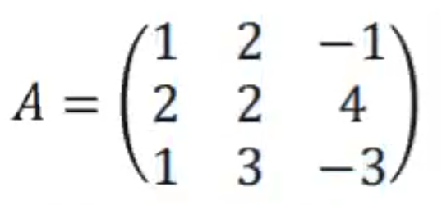

Step 1 : Augmented Matrix with an identity matrix

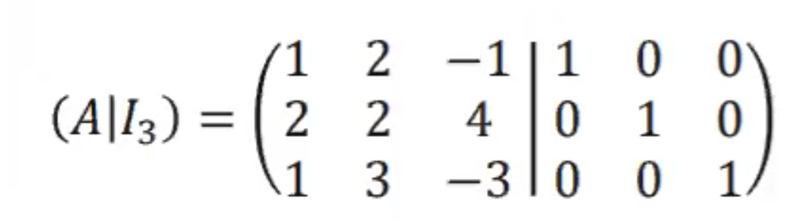

Step 2: Use Gaussian elimination such that the left side becomes an identity matrix. Once done the right is the inverse

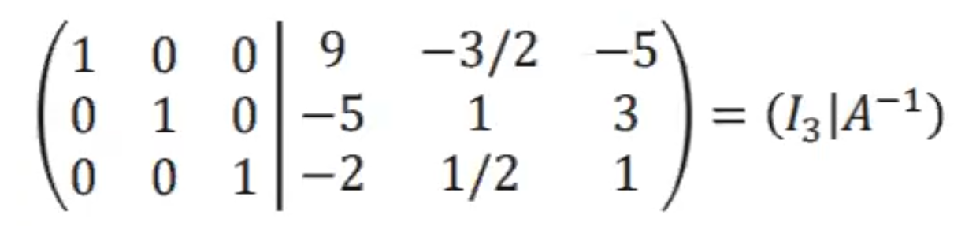

Non-invertible case:

Eg:

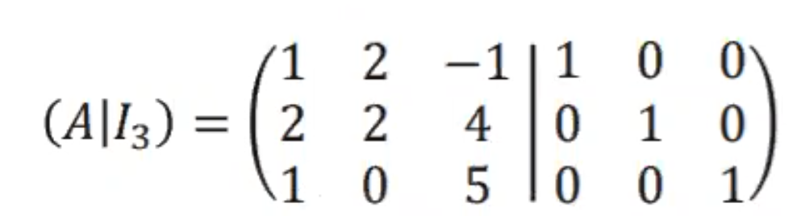

When doing g elimination:

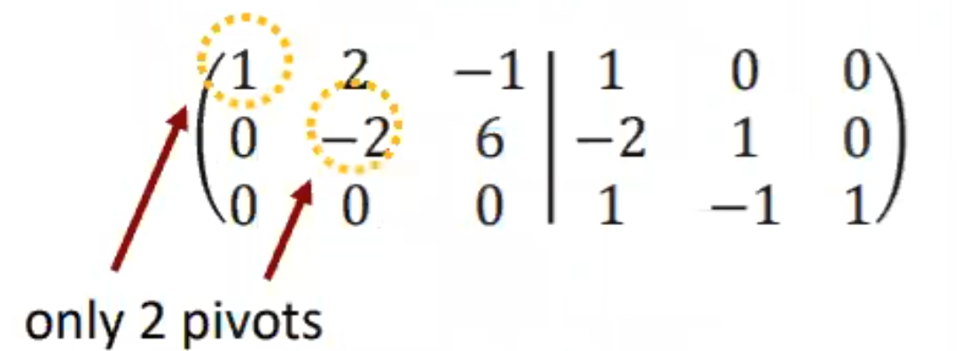

One of the full rows becomes 0 or one column does not have a pivot. This matrix is not invertible.

Non-invertible set has one or more vectors/column that is dependent on other hence overall they are a dependent set.

## Homogenous and inhomogenous solution set

|  |  |
| --- | --- |
| Given a inhomogeneous system | And its homogenous set is:  (obtained by moving constants to one side and made zero) |
|  |  |
| After Gaussian elimination => | After Gaussian elimination => |
| If you notice, the only difference between the two sets is one constant column, thus solution set of inhomogeneous systems can be rewritten as Ax0 + v = b. where x0 is the homogeneous system and v is a vector with scalars to be added to homogeneous system | |
| Vector (5 0 0) is called “particular solution” and obtained when x2 = x3 = 0. It is like a free variable, can be set to any “particular” and yet it will lead to a solution | The x2 and x3 coefficient vectors obtained are actually the span of the system of vectors. |
|  | Span is all linear combinations of system that can represent the system.  When it is ‘shifted’ (like added to it) by a particular vector, it becomes the original set being solved. |
|  | |

* To determine whether a set of vectors is linearly independent, write the vectors as columns of a matrix *A*, say, and solve *Ax*=0. If there are any nontrivial solutions (nontrivial = when x1/x2/x3 not = 0) then the vectors are linearly dependent; otherwise, they are linearly independent.
* The span of the rows of a matrix is called the **row space** of the matrix. The dimension of the row space is the **rank** of the matrix.
* The span of the columns of a matrix is called the **range** or the **column space** of the matrix. The row space and the column space always have the same dimension.

### Linear Systems and different ways of writing it:

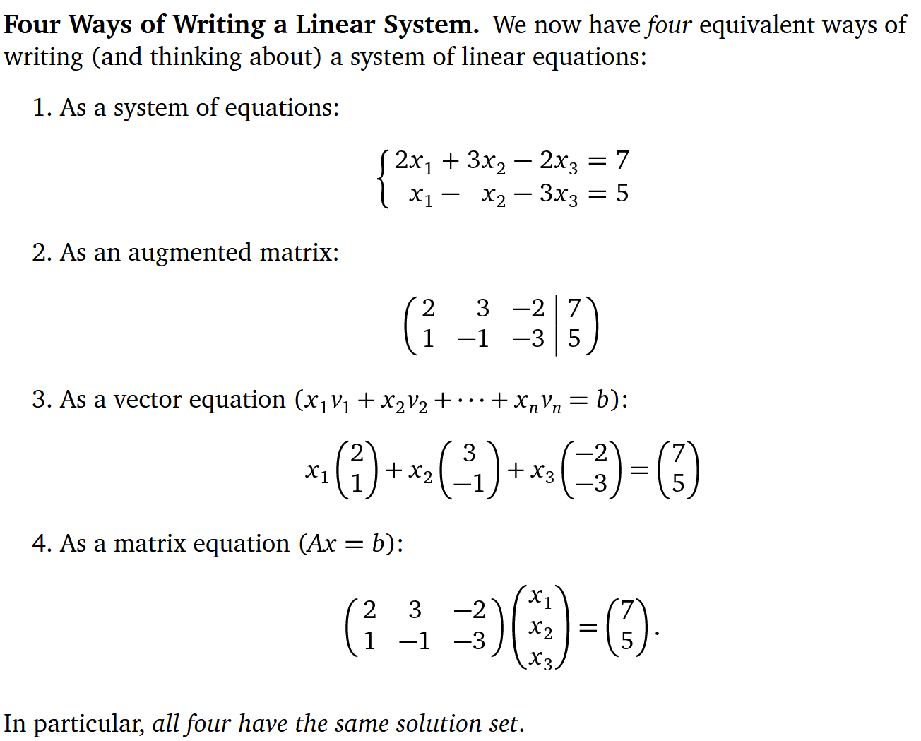

# Types of Linear Systems in Three Variables

Linear equation with 2 variables (x,y) represent a line and 3 variables represent a plane.

Linear equations can atmost have one of the below three relationship

1. One solution (When planes intersect such that there is only one common point/solution)
2. No solution ( if any planes are parallel and so no point meet)
3. Infinite solution (any of the planes are same hence infinite points solve the equations)

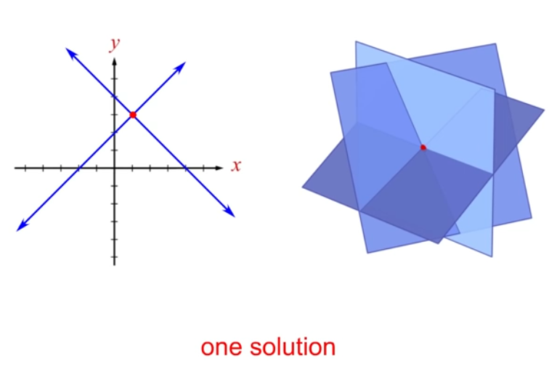

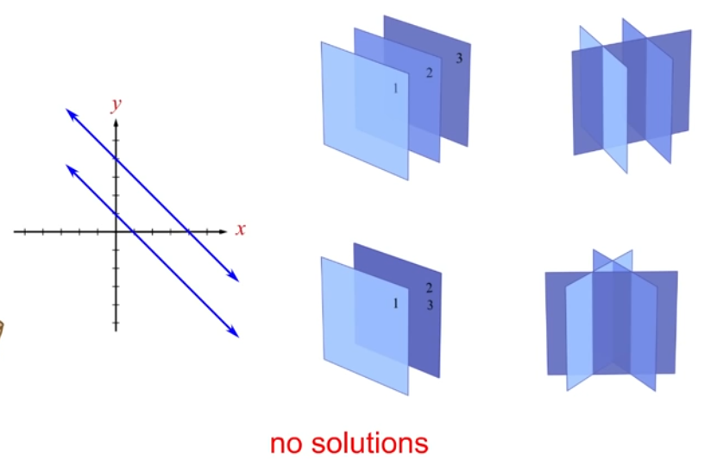

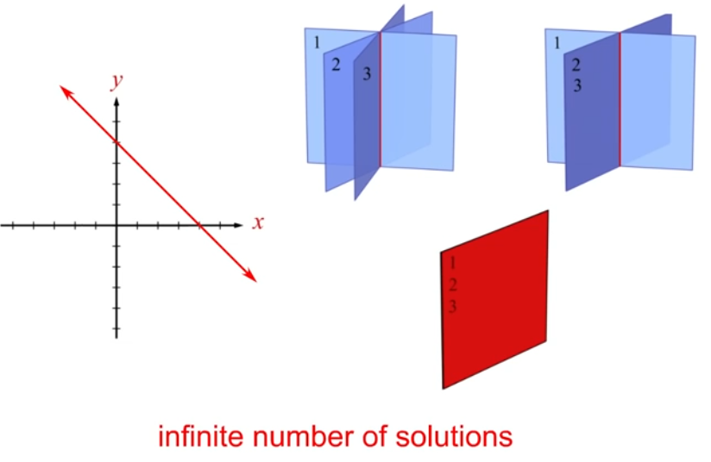

* a system with fewer equations than unknowns has infinitely many solutions, but it may have no solution. Such a system is known as an **underdetermined** system.
* Usually, a system with the same number of equations and unknowns has a single unique solution.
* Usually, a system with more equations than unknowns has no solution. Such a system is also known as an **overdetermined** system.

Types :

|  |  |
| --- | --- |
| Consistent | Inconsistent |
| One or infinite solution | No solution |

|  |  |
| --- | --- |
| Dependent (no new information) | Independent |
| Infinite solutions or identical are dependent | Eqns with distinct graphs are independent |

## Gaussian Elimination:

Gaussian elimination is an efficient technique to solve a system of linear equations for all possible solutions (if exist).

**Step 1:**

Rewrite the system in a simpler or **row echelon** form (without changing the solutions) using

**elementary row operations:**

* Swap any two rows
* Multiply a row by a non-zero scalar
* Add a multiple of one row to another row

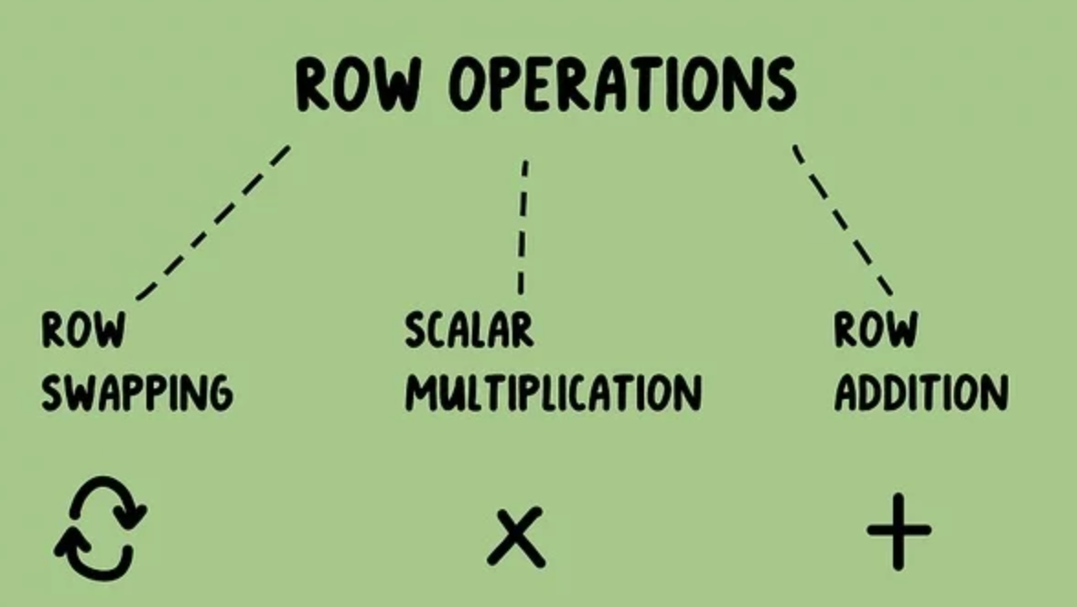

**Step 2:**

Reduce to row echelon form with row ops

### Row Echelon Form:

The row-echelon form is where the leading (first non-zero) entry of each row has **only zeroes below it**. These leading entries are called pivots, and an analysis of the relation between the pivots and their locations in a matrix can tell much about the matrix itself.

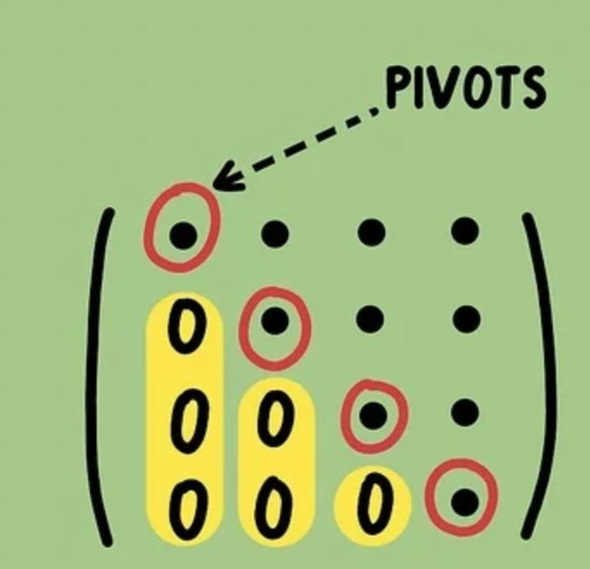

Row-reduce using row ops so that the entries below the pivots are 0 like above.

Note: Row echelon form can take many forms and is not unique hence two people can easily get two or more different reduced row echelon forms.

Eg of row reduction:

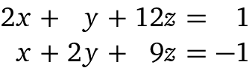

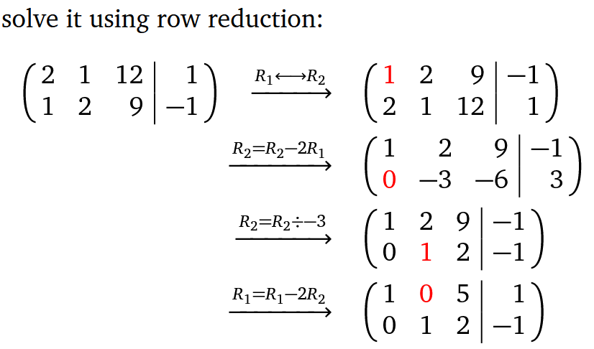

A matrix is in **row echelon form** (ref) when it satisfies the following conditions.

* The first non-zero element in each row, called the **leading entry**, is 1.
* Each leading entry is in a column to the right of the leading entry in the previous row.
* Rows with all zero elements, if any, are below rows having a non-zero element.

A matrix is in **reduced row echelon form** (rref) when it satisfies the following conditions.

* The matrix is in row echelon form (i.e., it satisfies the three conditions listed above).
* The leading entry in each row is the only non-zero entry in its column.

**Step 3:**

Use backward substitution to solve the simpler system and write the solution set in parametric form

**No Solution clues:**

(When do you know when there is no solution?)

* One of the rows become completely zero such that it is just a linear combination of other vectors and not adding any information for a solution
* When the echelon forms shows as 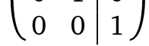 where 0 = 1 is implied

### Augmented Matrix:

A system of linear equations like

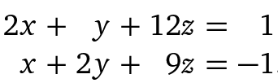

Can be represented in matrix form as:

Note: unknown variables must be on one side and constant on the other side

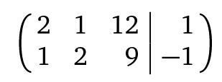

This is called **augmented matrix**

### Free Variable / Parameter :

In row reduction, you might come across a free variable.

In example above,



The reduced row echelon form is :

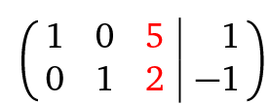

Note that z column is not a pivot column and yet the above equations have a solution. This makes z a free variable. z is aka non-leading variable since the entire column has no pivot/leading variable.

Hence any consistent system of eqns with non-leading / non-pivot unknown variable (like z) can

Free variable because, the solution can be written as below, derived from the z variable:

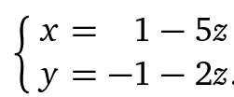

You pick a z, x and y and thus solution found. This is called a free variable and “parameter” thus above expression of the system of eqns is called “**Parametric form**”

Another way to define free variable/parametric form is independent / dependent variables. Any system in which all unknown variables (x,y) can be found based on the value of one other unknown variable z (by way of picking any real number) can be reduced to a parametric form. Here z is the independent variable and x,y are dependent variable (dependent on z).

Systems with infinite solutions are good suspects for to be written in parametric form.



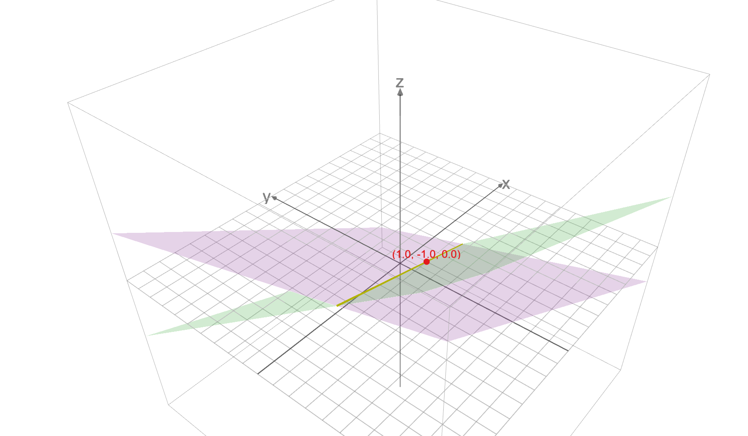

Above set of eqns are intersection of two planes. To get the solution, pick any z and you get x and y. But it has infinite solutions.

**Note:** Parametric form and Free variable is only possible in a “consistent” system which has a solution. Inconsistent systems cannot be written in parametric form

Representation of parametric form:

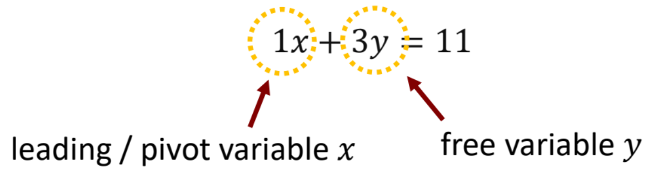

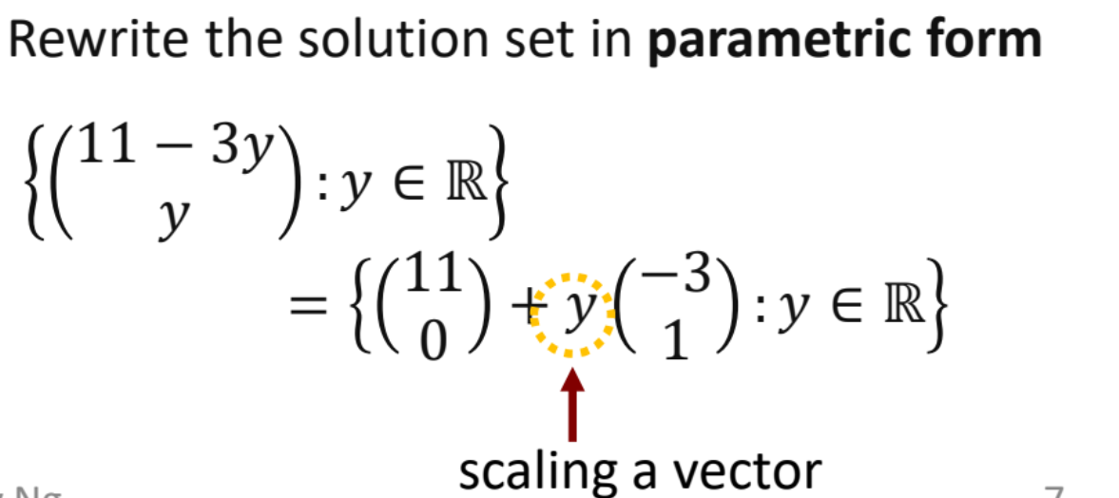

### Example of Gaussian elimination and parametric form:

Given:

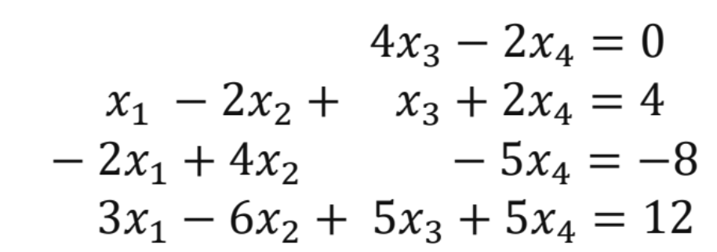

**Step 1:** augmented form:

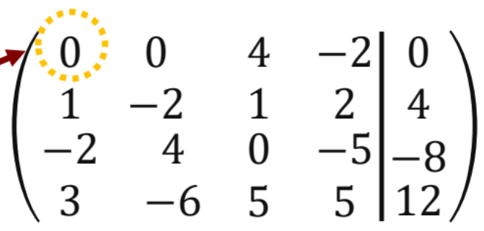

**Step 2:** Row reduction to echelon form

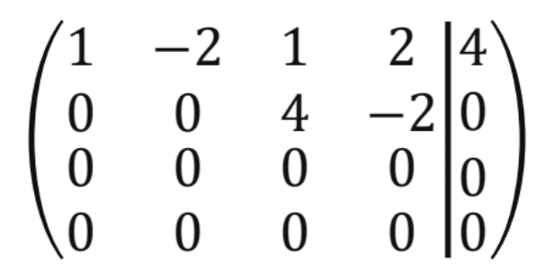

Note: 1 and 4 are the leading variables

**Step 3:** rearrange such that non-leading variables are on one side and leading variable on other.

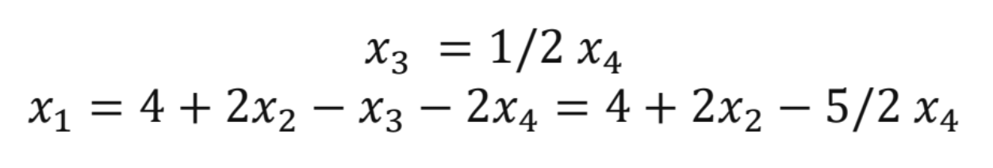

Note: Above system is not solvable since there are more unknown variables than no. of eqns which help solve for them. This is hence called under-determined system.

**Step 4:** Write in parametric form:

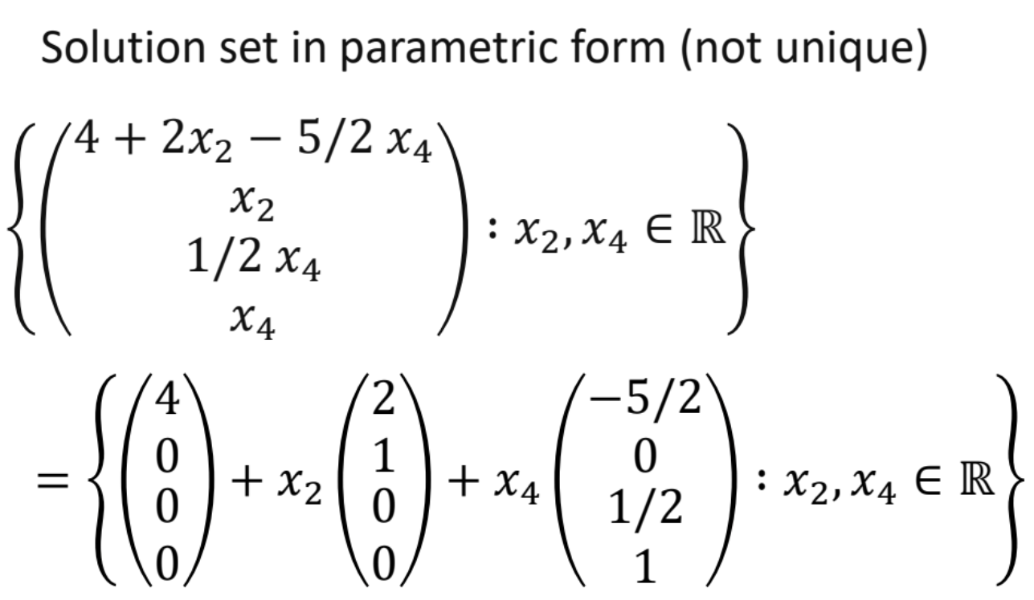

## Span:

Set of all linear combinations of vectors in question.

If the two or three or x vectors are all on one same line then the span is that one line extended to infinity

If the vectors in question have some angle between them , then their linear combinations set, aka span is all the points in the x-y plane

• The span of the rows of a matrix is called the row space of the matrix. The dimension of the row space is the rank of the matrix.

• The span of the columns of a matrix is called the range or the column space of the matrix. The row space and the column space always have the same dimension.

Span of a single vector is only a line

Span of two vectors are a plane

Span of 3 vectors is the whole 3d space itself

### Spanning set:

Any set of vectors that are not all linearly independent (while few are independent) but together they have the “span” of the vector space in question hence simply called spanning set.

Spanning set is not unique and have redundant vectors in the set.

## Vector Space :

The entire space/span (or collection of vectors) of given vectors in consideration such that

* any addition of vectors at hand or
* scalar multiplication or
* linear combination

results in a vector that is already in the vector space – span.

Vector space has to be

* “closed under vector addition” – fancy math term to say addition of given vectors results in a new vector already in the given span.
  + If any two vectors x and y are in the subspace, x + y is in the subspace as well.(ii)
* “closed under vector scalar multiplication”.
  + If we multiply any vector x in the subspace by any scalar c, cx is in the subspace as well.

## Subspace:

Subset of vector space is subspace.

x-y plane is subspace of R3 space

x axis line is subspace of R2

## Rank

Intuitive definition:

rank r of a matrix as the max number of dimensions that a linear combination of its columns would have; it tells, if one combined the vectors in its columns in some order, I'd get a set of coordinates for an r-dimensional space, where r is max.

* No of pivots/leading variables.
* Rank is the dimension of column space/ range of matrix
* The rank of a matrix is the dimension of the vector space spanned by the columns. So the number of pivots equals the rank. The number of non-zero rows also equals the rank.

Rank Properties:

1. Rank (A) = Rank(Tranpose A)

Eg: Rank of 3X4 matrix is same as its transpose 4X3 matrix.

Rank/linearly independent vectors is not only from column perspective but also rows.

1. Rank = no. of linearly indep. Vectors
2. Rank of a matrix cannot be larger than no. or rows or columns
3. When matrices are multiplied, the rank of product is equal to or lesser than those of original matrices

Let *A* be an *m*-by-*n* matrix. Then

1. rank(*A*) = dim(rowsp(*A*)) = dim(colsp(*A*))
2. rank(*A*) = number of [pivots](https://en.wikipedia.org/wiki/Pivot_element) in any echelon form of *A*,
3. rank(*A*) = the maximum number of linearly independent rows or columns of *A*.

Special matrices:

#### Rank 1 matrix:

When rank of matrix is 1, it can be rewritten as outer product of two matrices like.

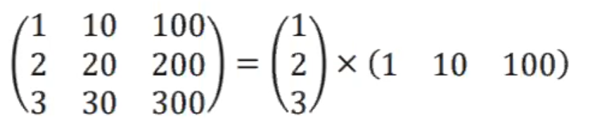

#### Full Rank:

When the rank of matrix is the max is can be, as in equal to the minimum of no. of rows or columns, it is called full rank.

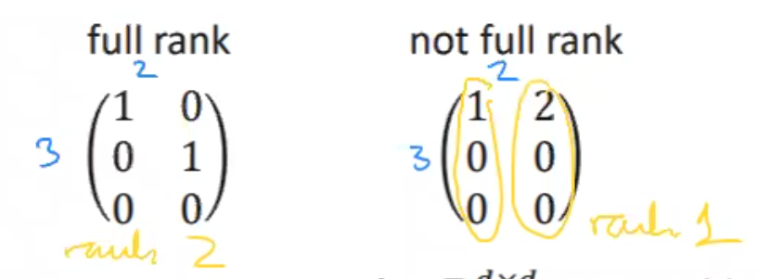

Full rank tells

* If a square matrix, it is invertible and/or the columns are lin. Independent
* If non-square, it can be slightly modified to be made invertible like adding a column of identity. Etc. A full rank non square matriz is close to being invertible. (important fact in linear regression. As in, does the input matrix is full rank or not, which implies if the fitted-linear model has **unique** coefficients or not.

## Dimension of the solution set

When there is one free variable in a consistent matrix equation, the solution set is a line, and when there are two free variables, the solution set is a plane, etc. The number of free variables is called the dimension of the solution set.

AKA:

* Dimension is also the number of linearly independent vectors in a span.
* Dimension is also the number of vectors in a vector space basis.

EG: 2D and 3D

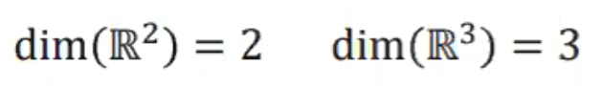

### Different applications of concept of dimension:

Just memorize since it is nothing new but just a different angle to linear alg.

Below k is the given vectors or vectors at hand while d is the dimension of vector space

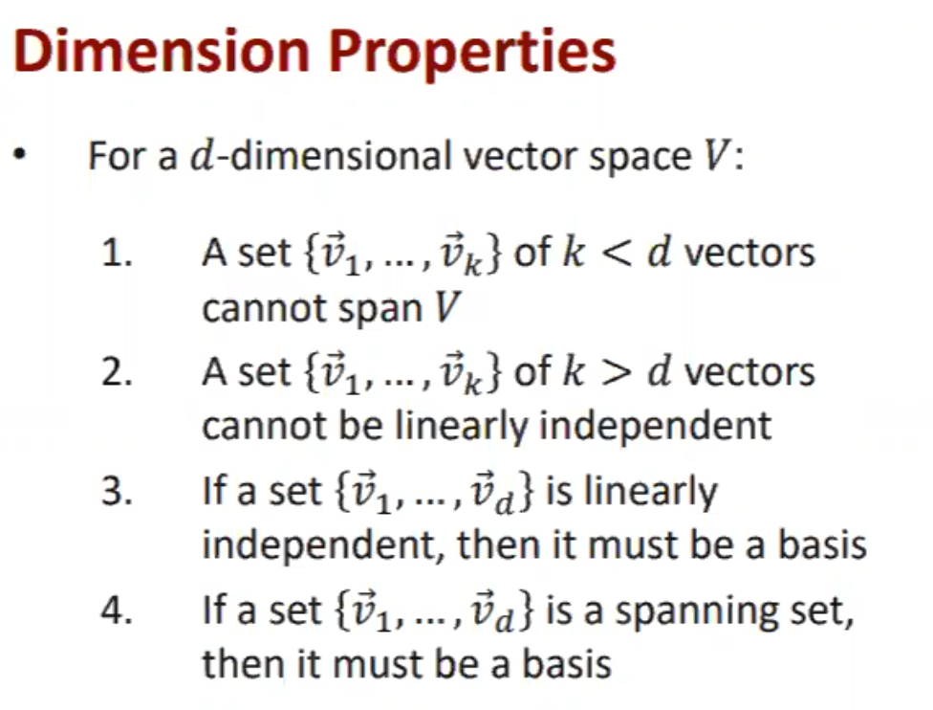

## Column space/ Range of matrix:

Column space is simply the minimum set of independent vectors of a given matrix.

Eg: Vector A is given. 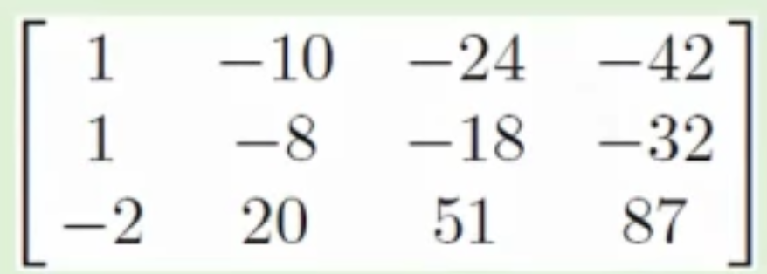

There are 3 rows so the object should be a 3d object in R3. But we don’t need 4 vectors/columns to define it and so reduce the matrix to row echelon form such that independent vectors/columns alone remain. Redundant vectors are removed and thus gives us Column space.

How to find it:

Step1: Reduce given matrix to row echelon form



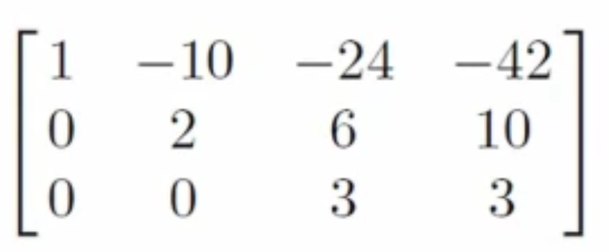

Step 2: Identify the columns with pivots

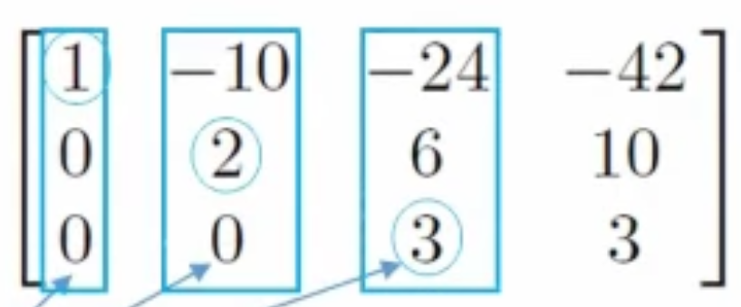

Step 3: the corresponding columns from the original matrix simply gives the Column space of Matrix A.

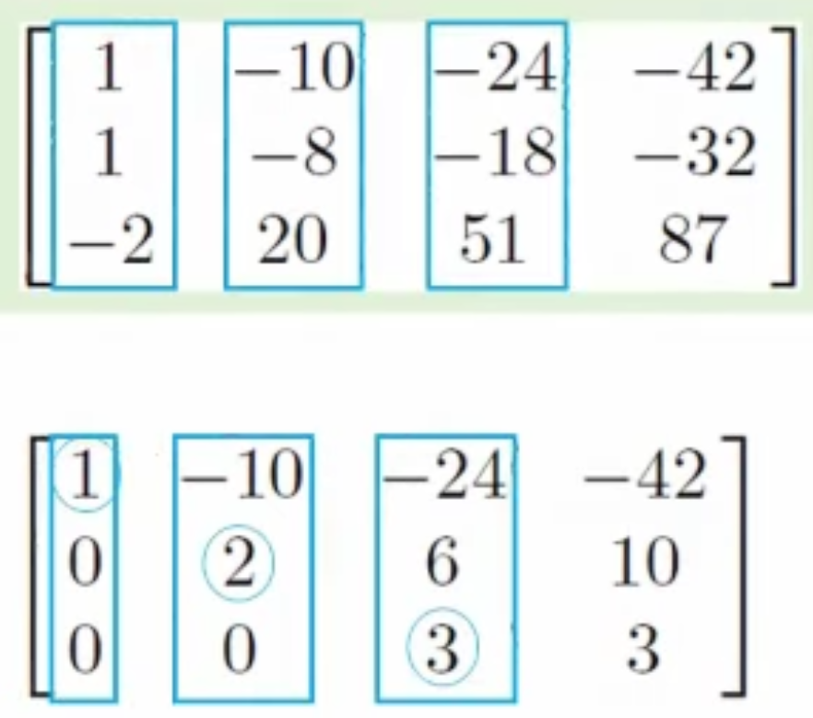

Note:

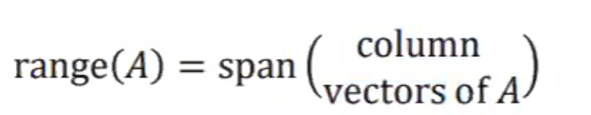

Column space of a matrix = span of the columns of A

= set of all linear combinations of the columns of A

Column Space of [ 1 1 2]

## Application of Column space:

Given Ax = b, now vector b is a vector in the span of matrix A.

Vector b is in the range/column space of matrix A.

If one says, vector b is in the range of matrix A, it is adv. Math way of saying the matrix has a solution.

### Nullity of matrix

Nullity is simply the no. of free variables.

Nullity also = dimension of null space of matrix

## Null space

Null Space is another fundamental space in a matrix, being the set of all vectors which end up as zero when the transformation is applied to them. ... In this case, that line is the set of all vectors that ended up on the zero vector under the transformation, so it is the Null Space.

Other definitions:

If AA is your matrix, the null-space is simply put, the set of all vectors vv such that A⋅v=0A⋅v=0. It's good to think of the matrix as a linear transformation; if you let h(v)=A⋅vh(v)=A⋅v, then the null-space is again the set of all vectors that are sent to the zero vector by hh. Think of this as the set of vectors that lose their identity as hh is applied to them. the "loses their identity" part made so much sense! So that is why, when we reduce the dimensions of an m * n matrix, the number of vectors that don't lose their identity (the number of pivot columns) + the number of vectors that do (which is dim Null A) is just the total number of columns, n. *Take the projection on first dimension A=[1,0]A=[1,0]. Both vectors (0,19)(0,19) and (0,333)(0,333) are 00s in the target. How can you "undo" this zero to get the 19 and 333 back? Once mapped by the transformation, they become the same - lose their identity.*

Example of Null space:

Imagine a set of map directions at the entrance to a forest. You can apply the directions to different combinations of trails. Some trail combinations will lead you back to the entrance. They are the null space of the map directions.

Let's suppose that the matrix A represents a physical system. As an example, let's assume our system is a rocket, and A is a matrix representing the directions we can go based on our thrusters. So what do the null space and the column space represent?

Well let's suppose we have a direction that we're interested in. Is it in our column space? If so, then we can move in that direction. The column space is the set of directions that we can achieve based on our thrusters. Let's suppose that we have three thrusters equally spaced around our rocket. If they're all perfectly functional then we can move in any direction. In this case our column space is the entire range. But what happens when a thruster breaks? Now we've only got two thrusters. Our linear system will have changed (the matrix A will be different), and our column space will be reduced.

What's the null space? The null space are the set of thruster intructions that completely waste fuel. They're the set of instructions where our thrusters will thrust, but the direction will not be changed at all.

Another example: Perhaps A can represent a rate of return on investments. The range are all the rates of return that are achievable. The null space are all the investments that can be made that wouldn't change the rate of return at all.

Another example: room illumination. The range of A represents the area of the room that can be illuminated. The null space of A represents the power we can apply to lamps that don't change the illumination in the room at all.

To find the null space / **kernel of a matrix A** is the same as to solve the system AX = 0

Given matrix A, null space is the matrix that will make A 0.

How to find?

Step 1: AX = 0 is the homogeneous system(HS).

Step 2: After reducing HS to row echelon form, write the algebraic expressions in terms of x1,x2,x3. Simply and remove X and this gives the null space matrix

Note:

* ‘basis’ for the Null space can be found by reducing further. Coefficients of null space matrix the basis??

## Rank-Nullity Theorem:

Rank – No of pivots/leading variables. Rank is also the dimension of matrix.

Nullity = No of free variables/ non pivots

n, no. of columns of original matrix = Rank(A) + Nullity(A)

## Maximal Linearly Independent set:

Maximum number of vectors to define a vector space before one of them become dependent.

So basically reducing given number of vectors to the minimal few that are independent to each other.

How to identify?

* In the reduced row echelon form, the columns with the leading variable/pivots form the independent set. The other columns are dependent on one of the pivot columns.
* Given that Reduced row echelon form can be done in many ways, the Maximal Linearly Independent is not unique.

Eg: given

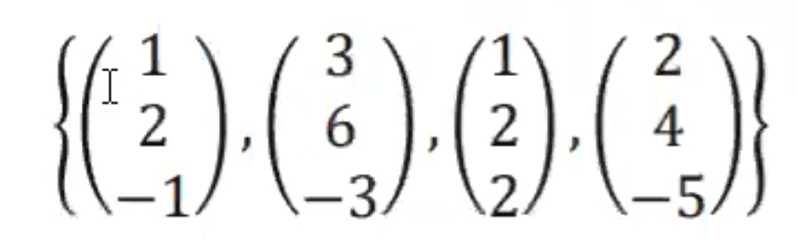

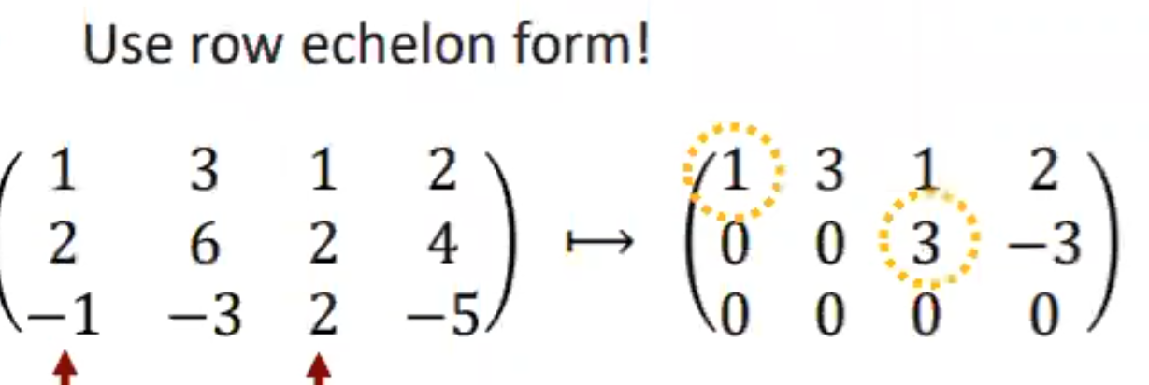

Testing dependence:

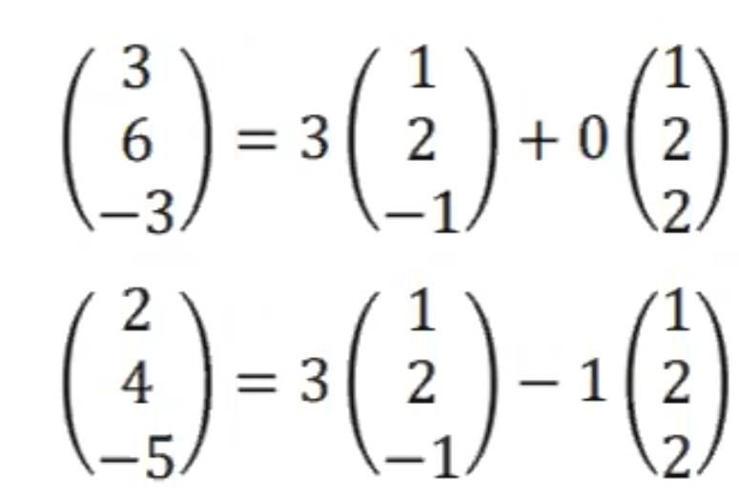

Maximal linearly independent set are:

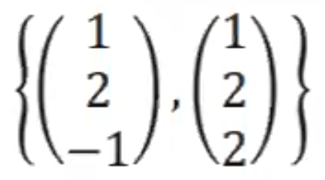

Above set is not unique, the row echelon form can be done differently such that it shows 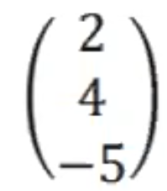 to be part of max. lin, inde set instead of 